Binyah BP Creation

Home - Personal - Microsoft​ Edge

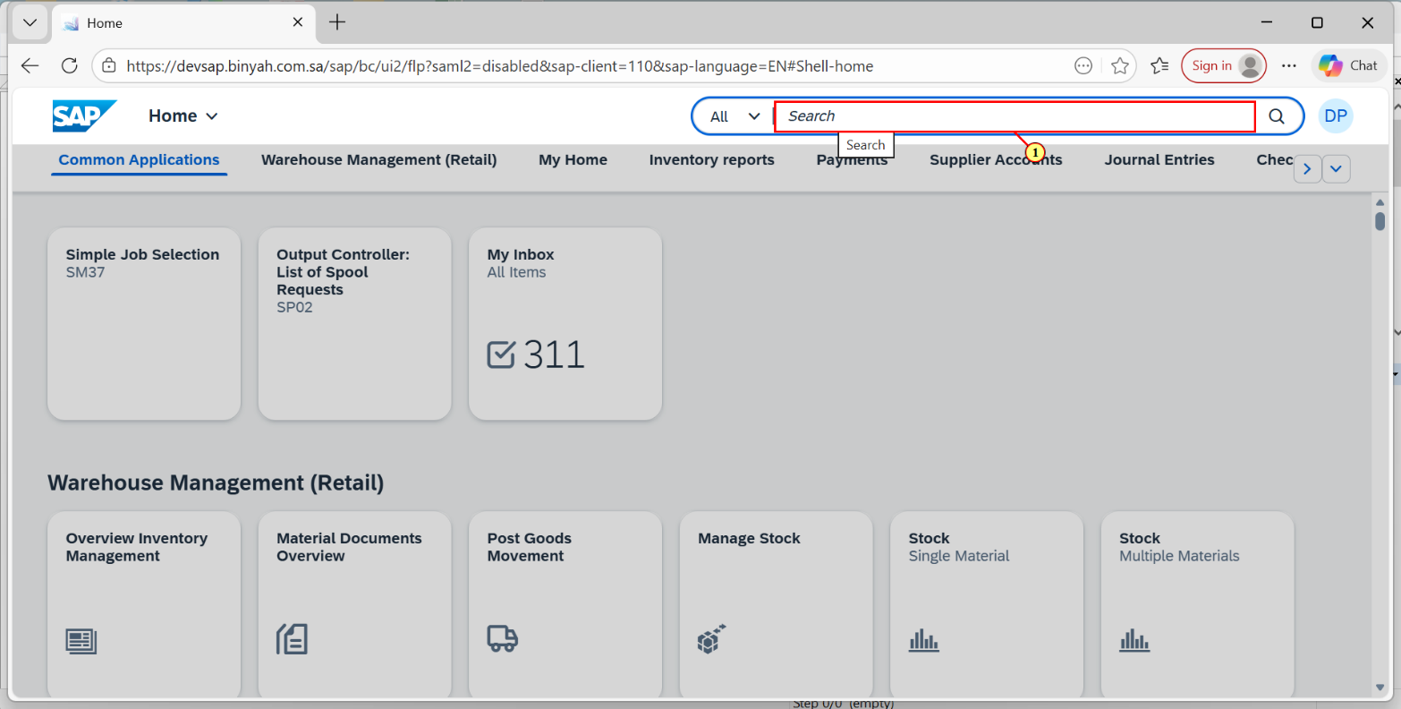

| Step | Action |
| --- | --- |
| (1) | The **Search** field is filled out. |

Home - Personal - Microsoft​ Edge

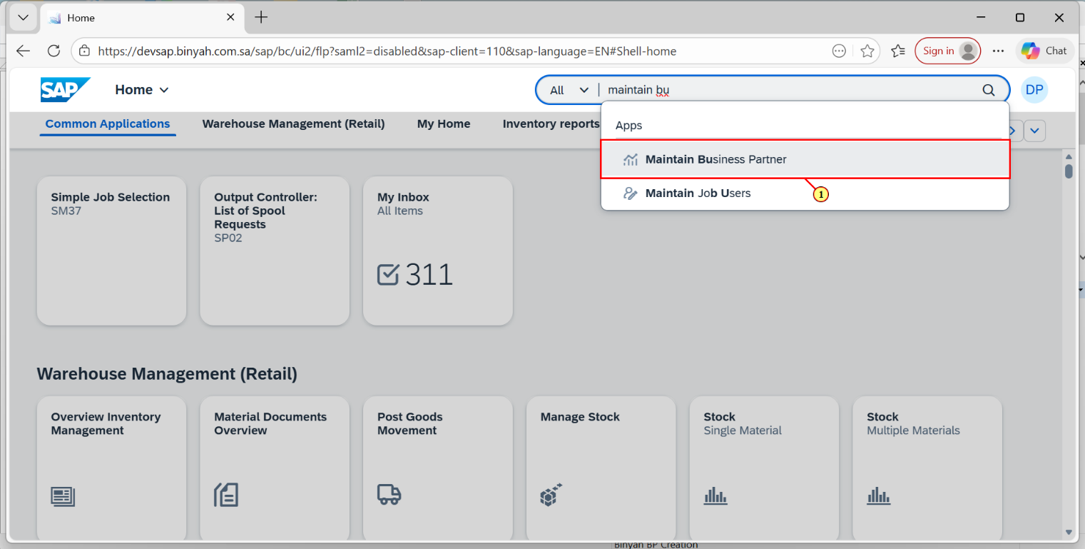

| Step | Action |
| --- | --- |
| (1) | Click **Maintain Business Partner** |
|  |  |

Maintain Business Partner - Personal - Microsoft​ Edge

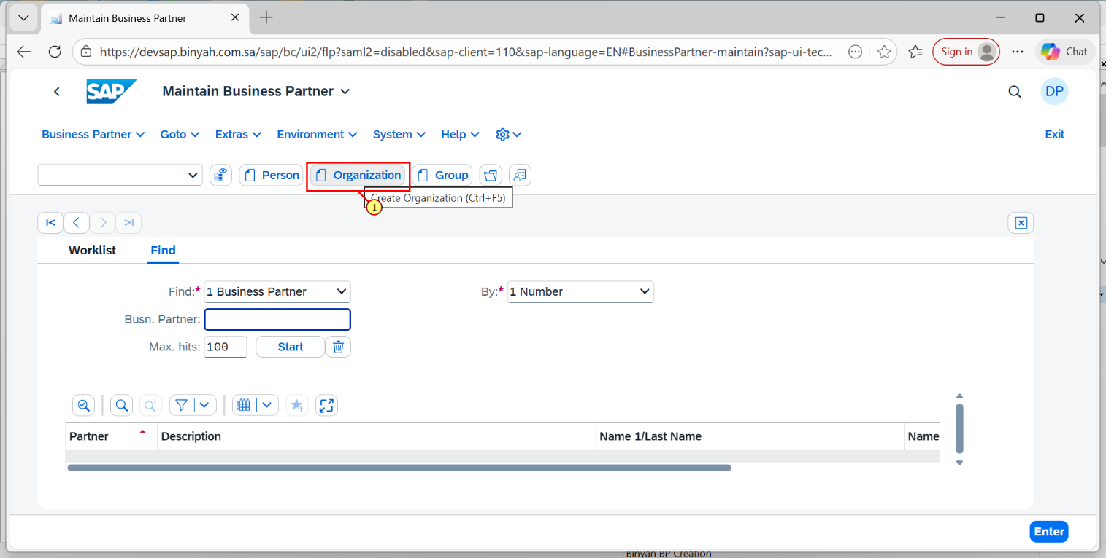

| Step | Action |
| --- | --- |
| (1) | Click On Organization |

Create Organization - Personal - Microsoft​ Edge

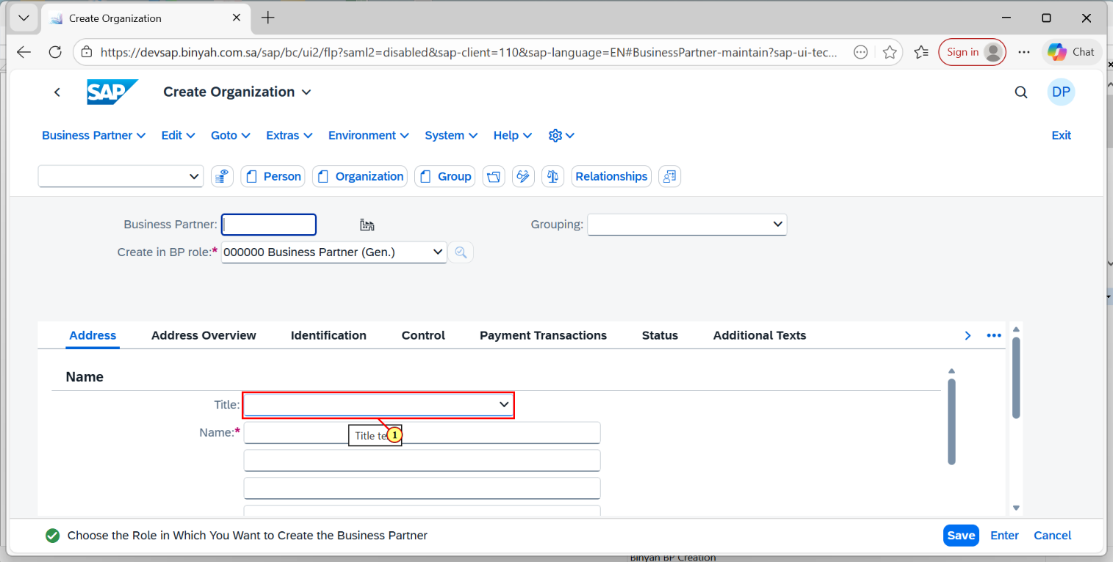

| Step | Action |
| --- | --- |
| (1) | Click on Title Dropdown menu and select "Company 0003". |

Create Organization - Personal - Microsoft​ Edge

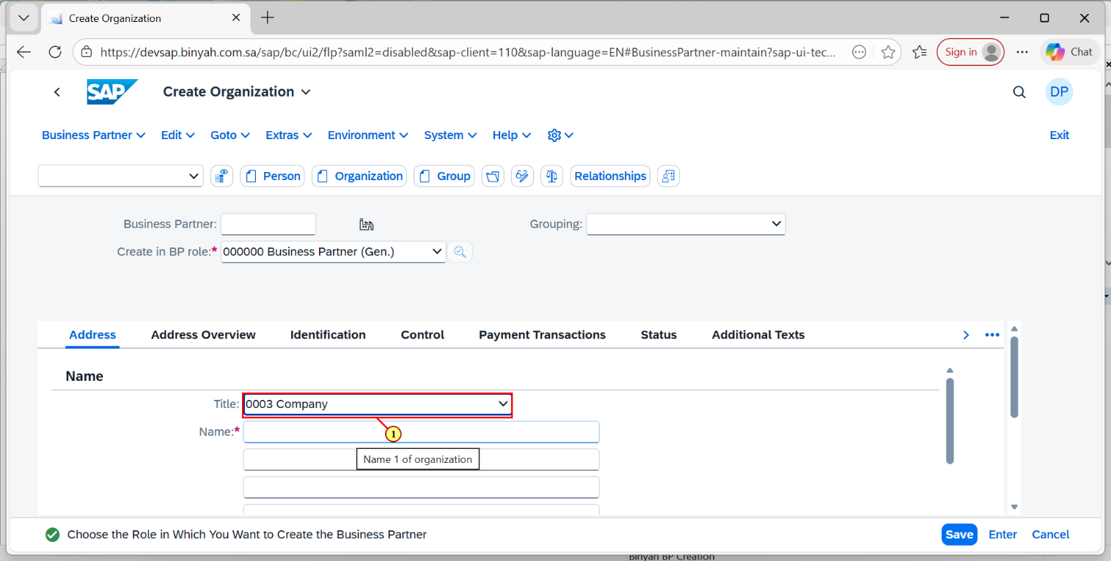

| Step | Action |
| --- | --- |
| (1) | Click Enter to fill "0003 Company". |

Create Organization - Personal - Microsoft​ Edge

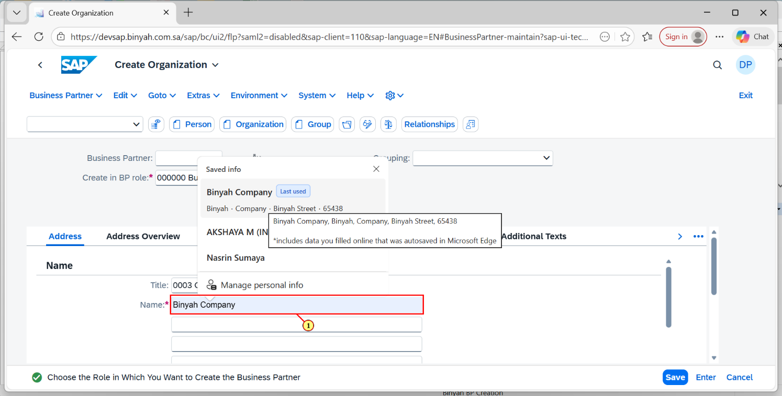

| Step | Action |
| --- | --- |
| (1) | Enter the Name of the Company in Name field and then click Enter. |

Create Organization - Personal - Microsoft​ Edge

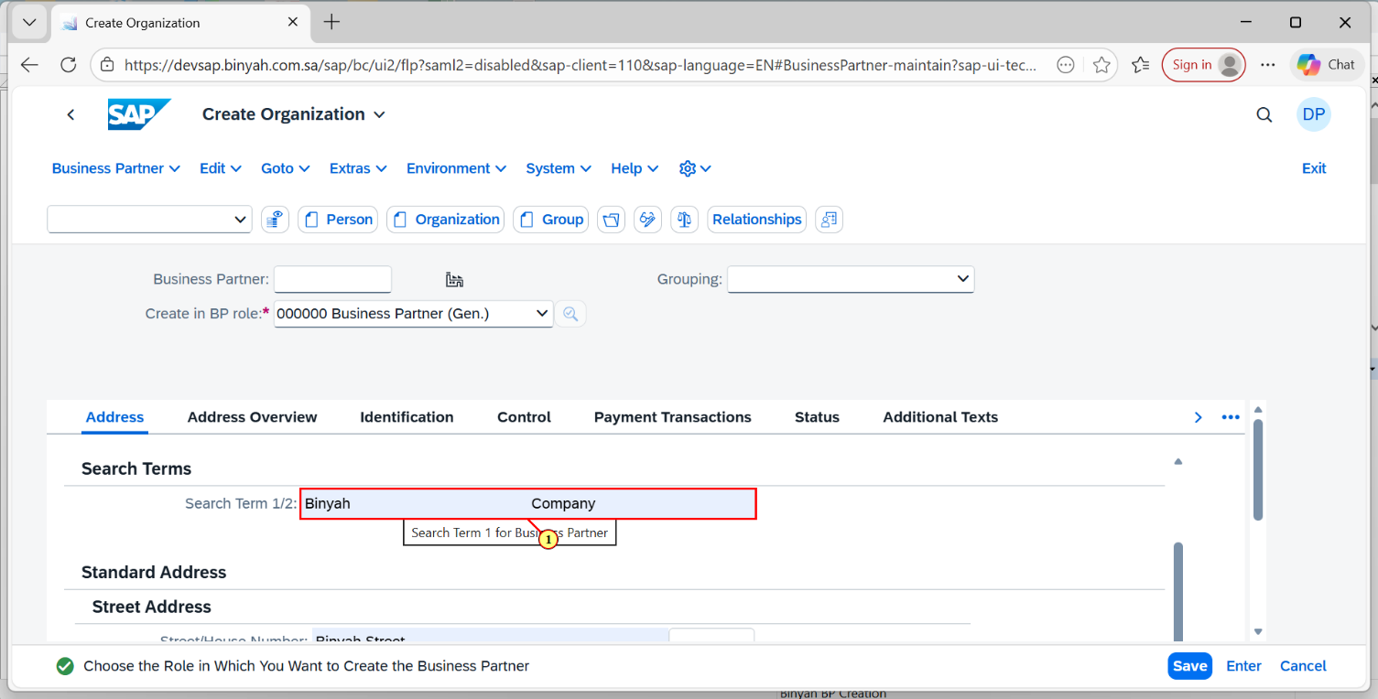

| Step | Action |
| --- | --- |
| (1) | Click on Search Term Box and Enter the Terms present in your "Company Name" and Click Enter. |

Create Organization - Personal - Microsoft​ Edge

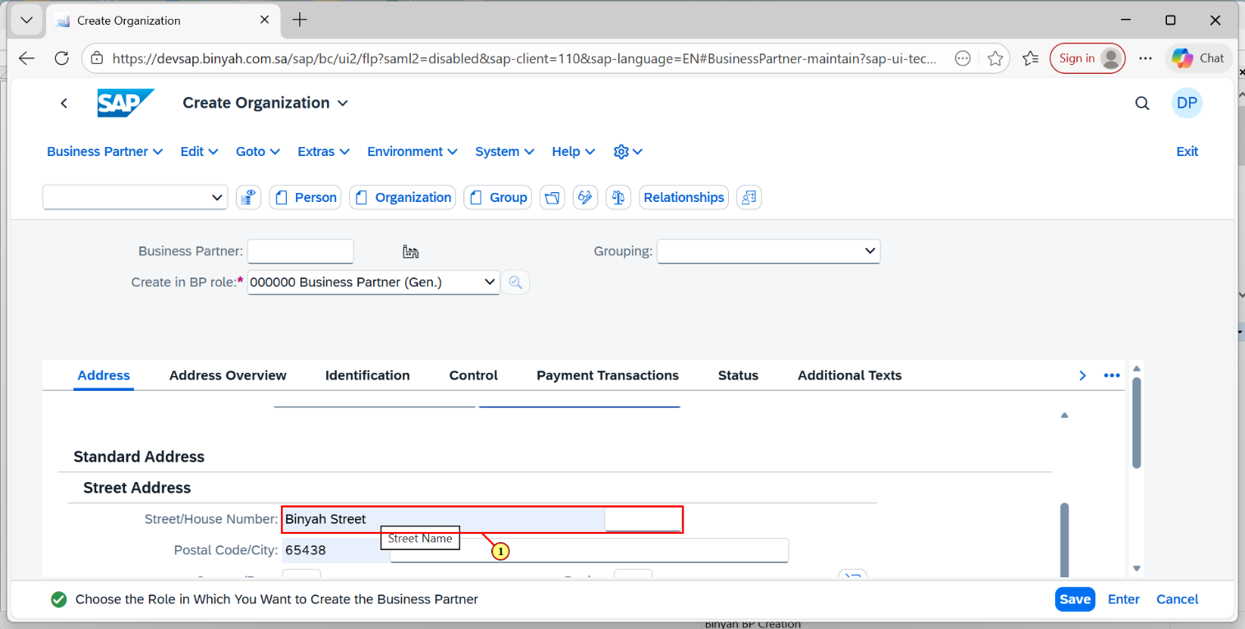

| Step | Action |
| --- | --- |
| (1) | In Address Tab, Enter the Street and House Number detail. |

Create Organization - Personal - Microsoft​ Edge

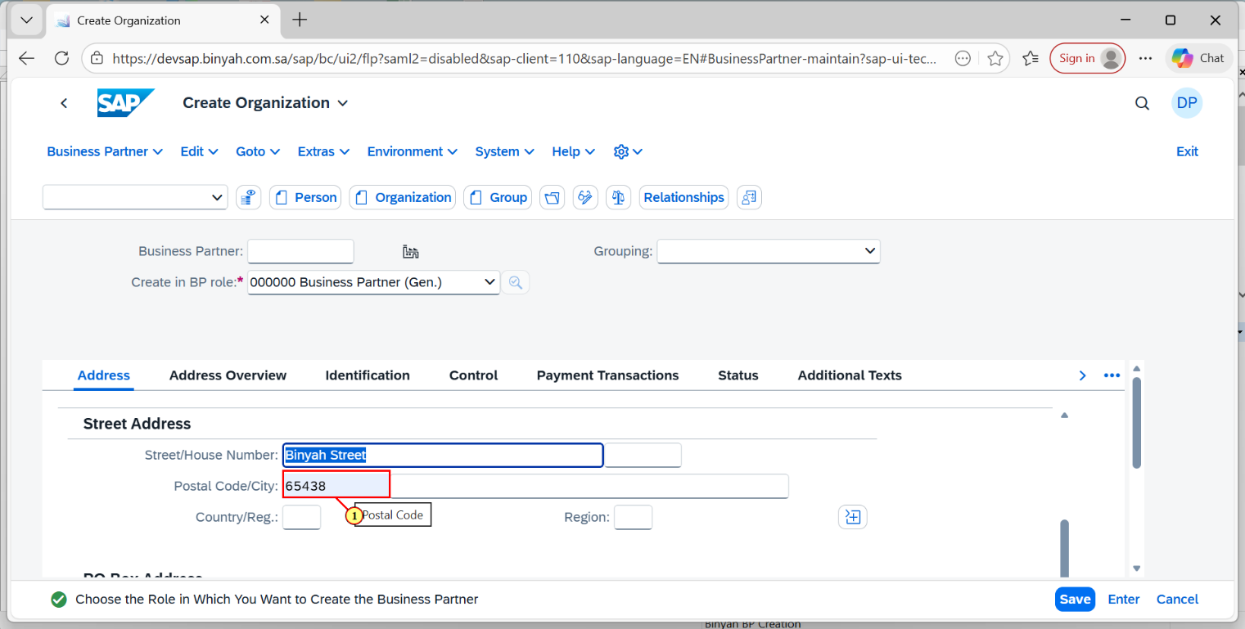

| Step | Action |
| --- | --- |
| (1) | Enter Postal Code in the given field. |

Create Organization - Personal - Microsoft​ Edge

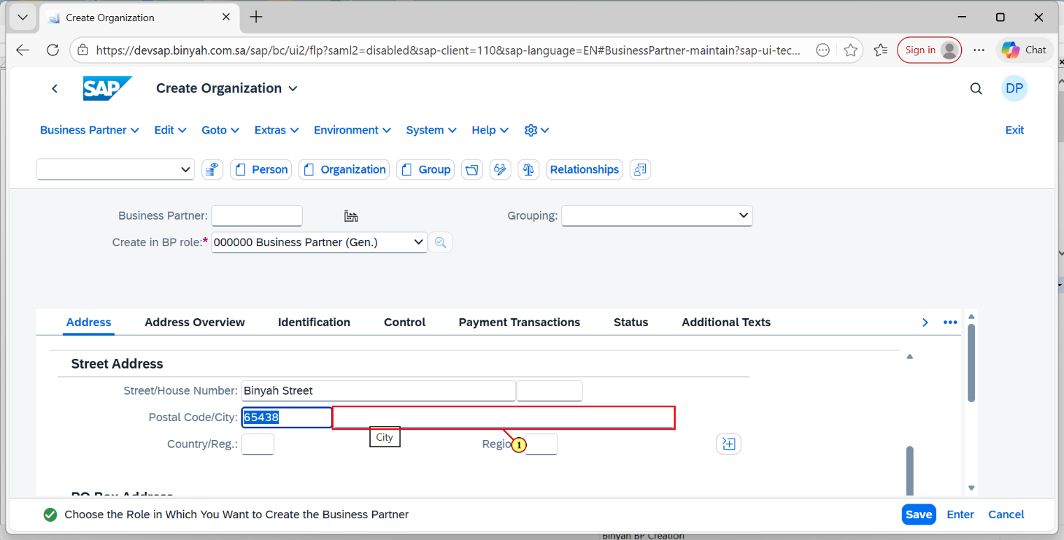

| Step | Action |
| --- | --- |
| (1) | Enter the City in the given Field. |

Create Organization - Personal - Microsoft​ Edge

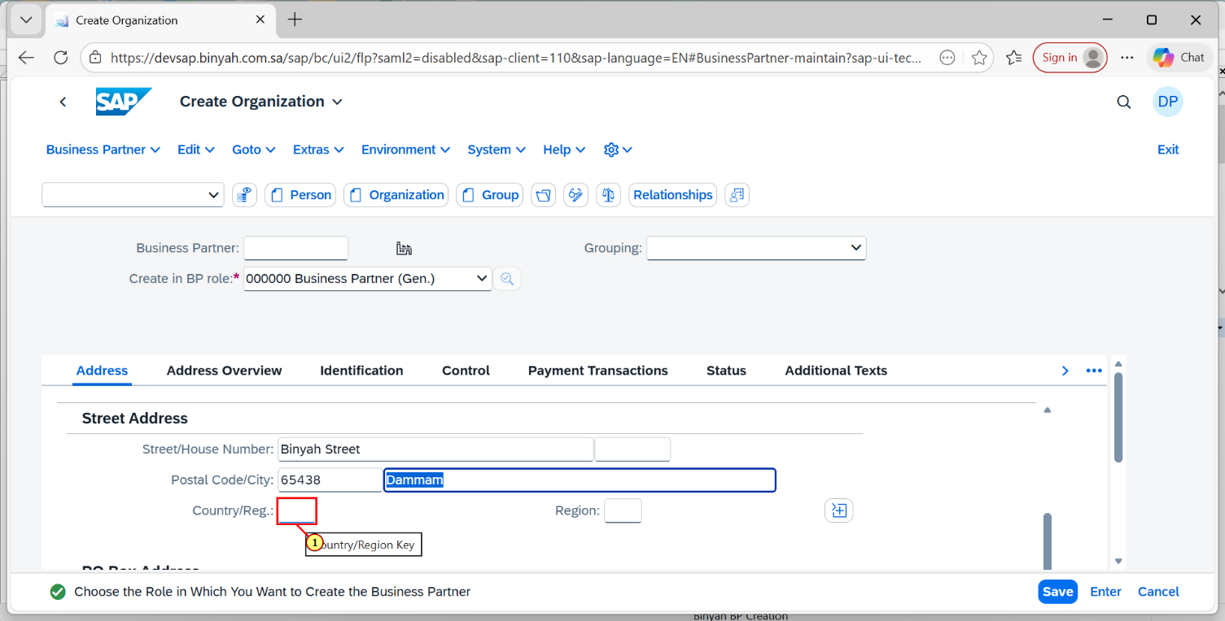

| Step | Action |
| --- | --- |
| (1) | Using search help enter the Country/Reg in the field. |

Create Organization - Personal - Microsoft​ Edge

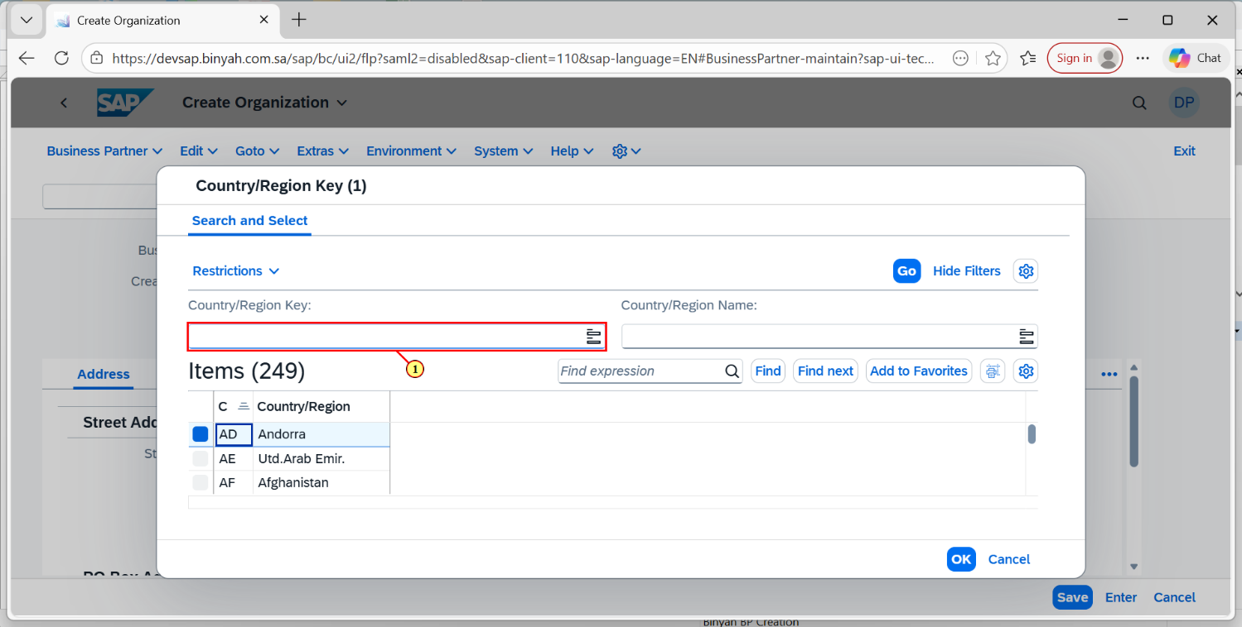

| Step | Action |
| --- | --- |
| (1) | After clicking the Search help of Country/Reg, it will navigate to this page.Here in the Search help box enter the terms. |

Create Organization - Personal - Microsoft​ Edge

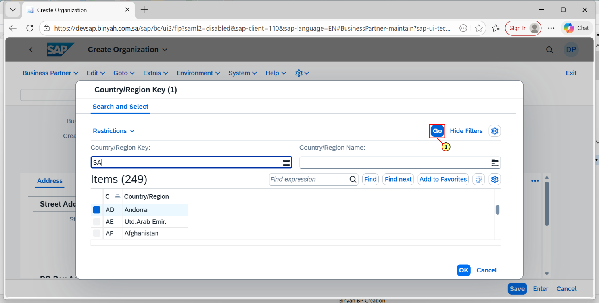

| Step | Action |
| --- | --- |
| (1) | Click on "GO". |

Create Organization - Personal - Microsoft​ Edge

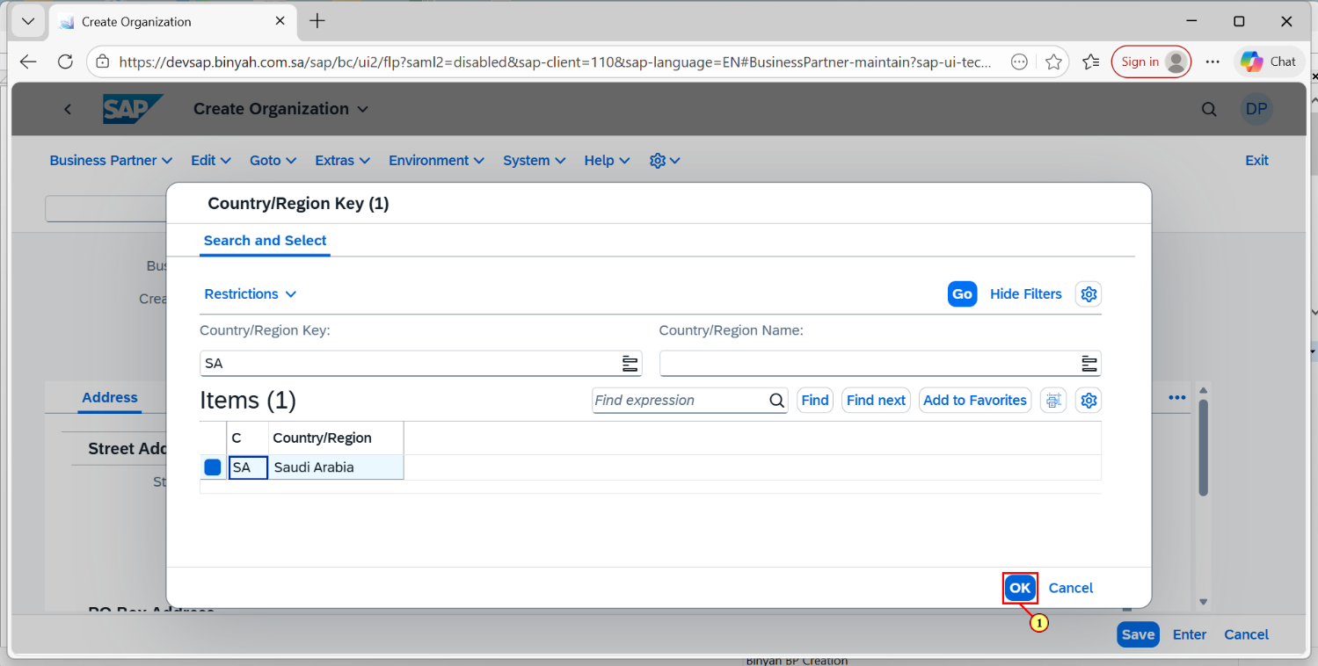

| Step | Action |
| --- | --- |
| (1) | After selecting the Required Field .Click "OK". |

Create Organization - Personal - Microsoft​ Edge

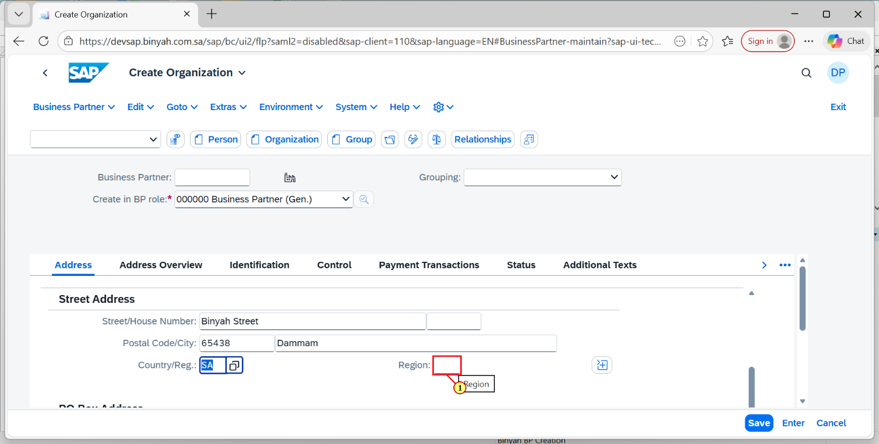

| Step | Action |
| --- | --- |
| (1) | Enter the Region by the using Search help. |

Create Organization - Personal - Microsoft​ Edge

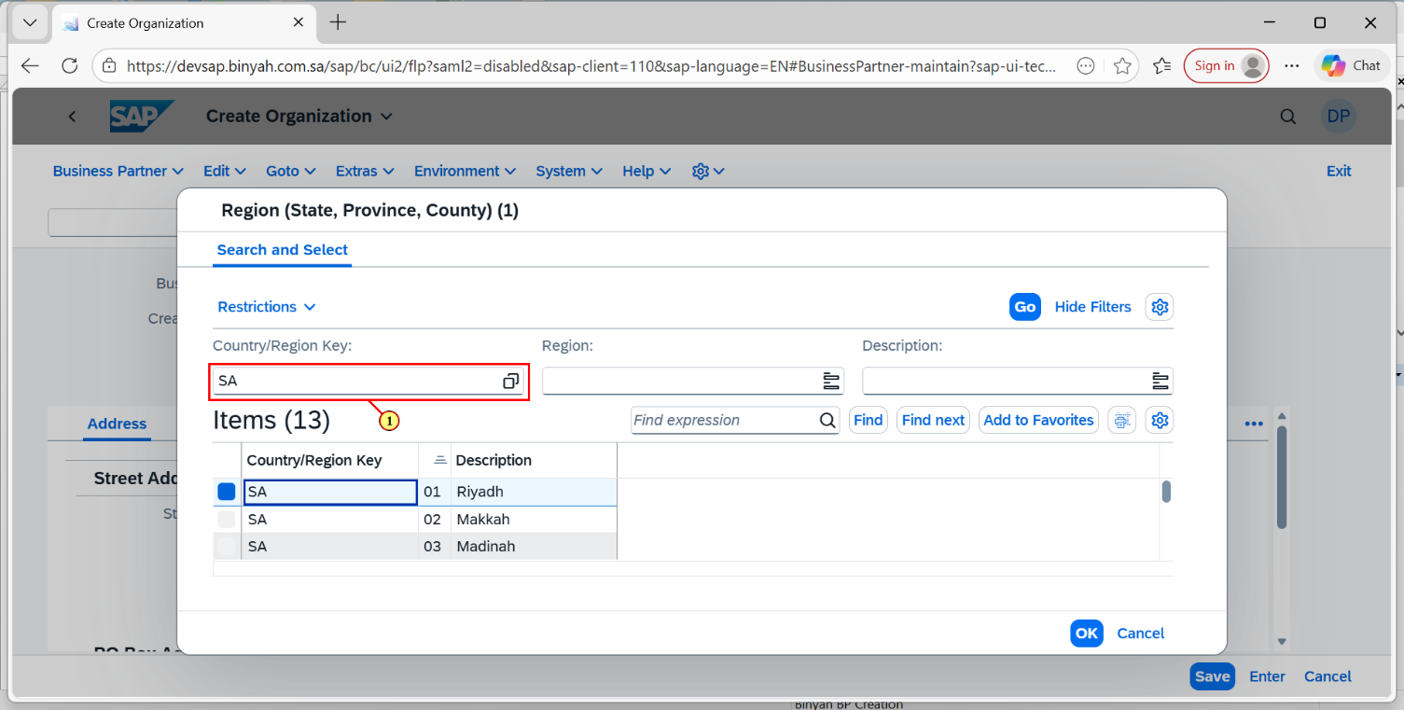

| Step | Action |
| --- | --- |
| (1) | Enter the Search Terms in the Given Field.and then Click on "GO". |

Create Organization - Personal - Microsoft​ Edge

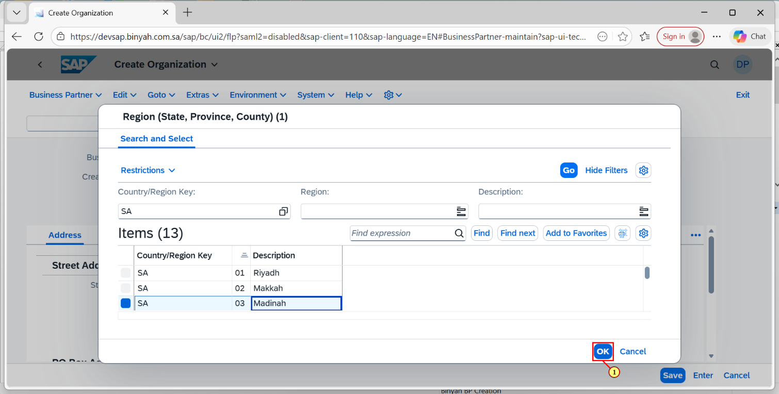

| Step | Action |
| --- | --- |
| (1) | After selecting the Region, Click on "OK". |

Create Organization - Personal - Microsoft​ Edge

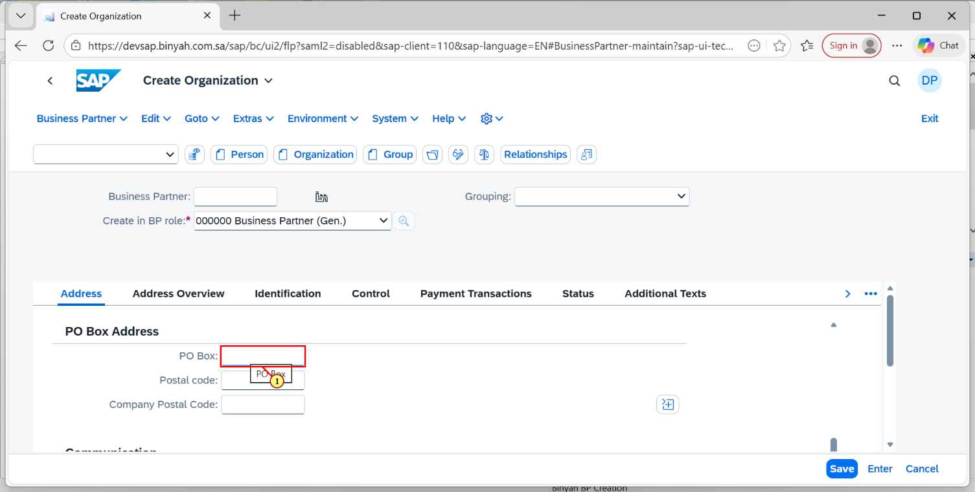

| Step | Action |
| --- | --- |
| (1) | Enter the PO Box number in the given Field. |

Create Organization - Personal - Microsoft​ Edge

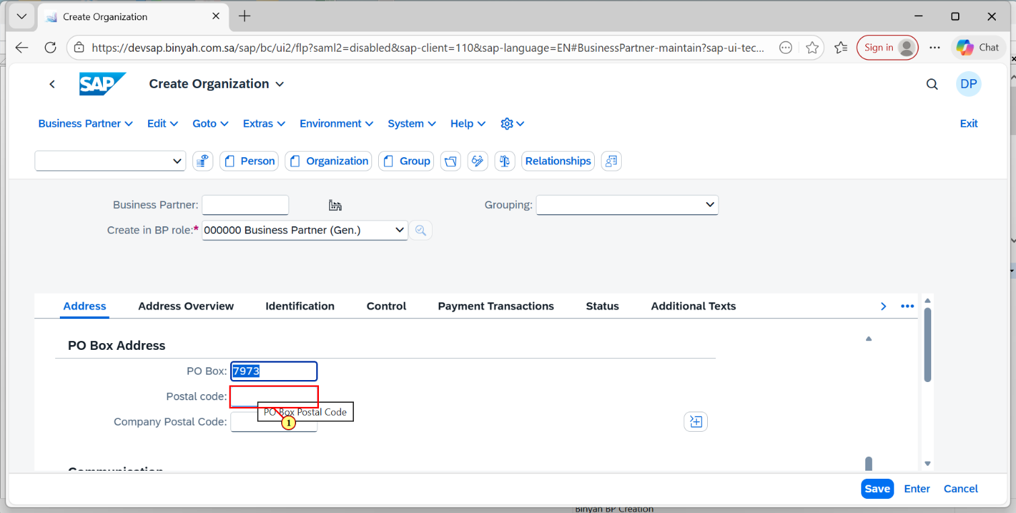

| Step | Action |
| --- | --- |
| (1) | Now enter the Postal code number in the mentioned field. |

Create Organization - Personal - Microsoft​ Edge

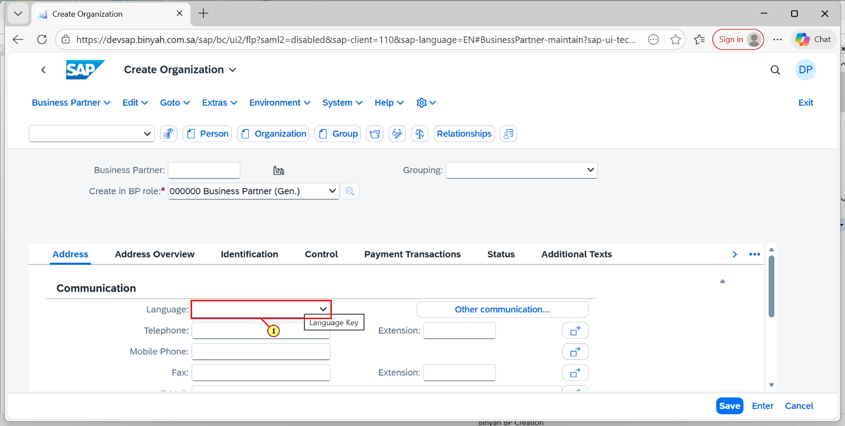

| Step | Action |
| --- | --- |
| (1) | Click On Language Search help to select the Language. |

Create Organization - Personal - Microsoft​ Edge

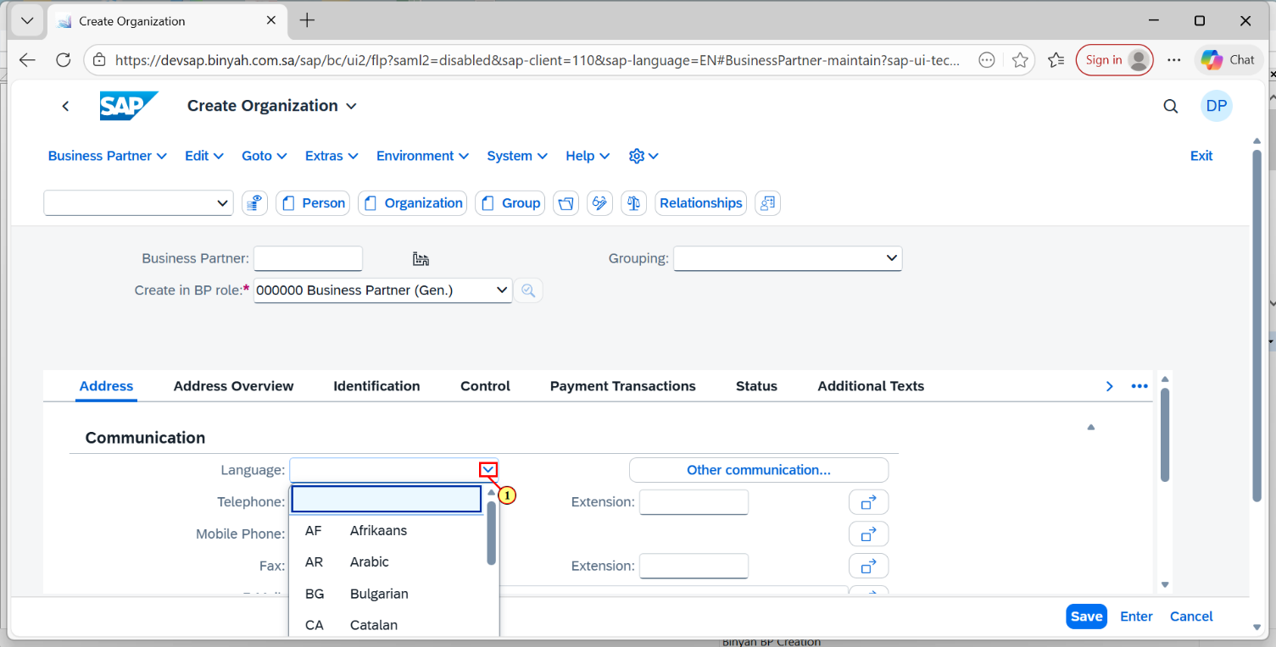

| Step | Action |
| --- | --- |
| (1) | After Clicking on Search help.Select the Required Language from the list of Languages. |

Create Organization - Personal - Microsoft​ Edge

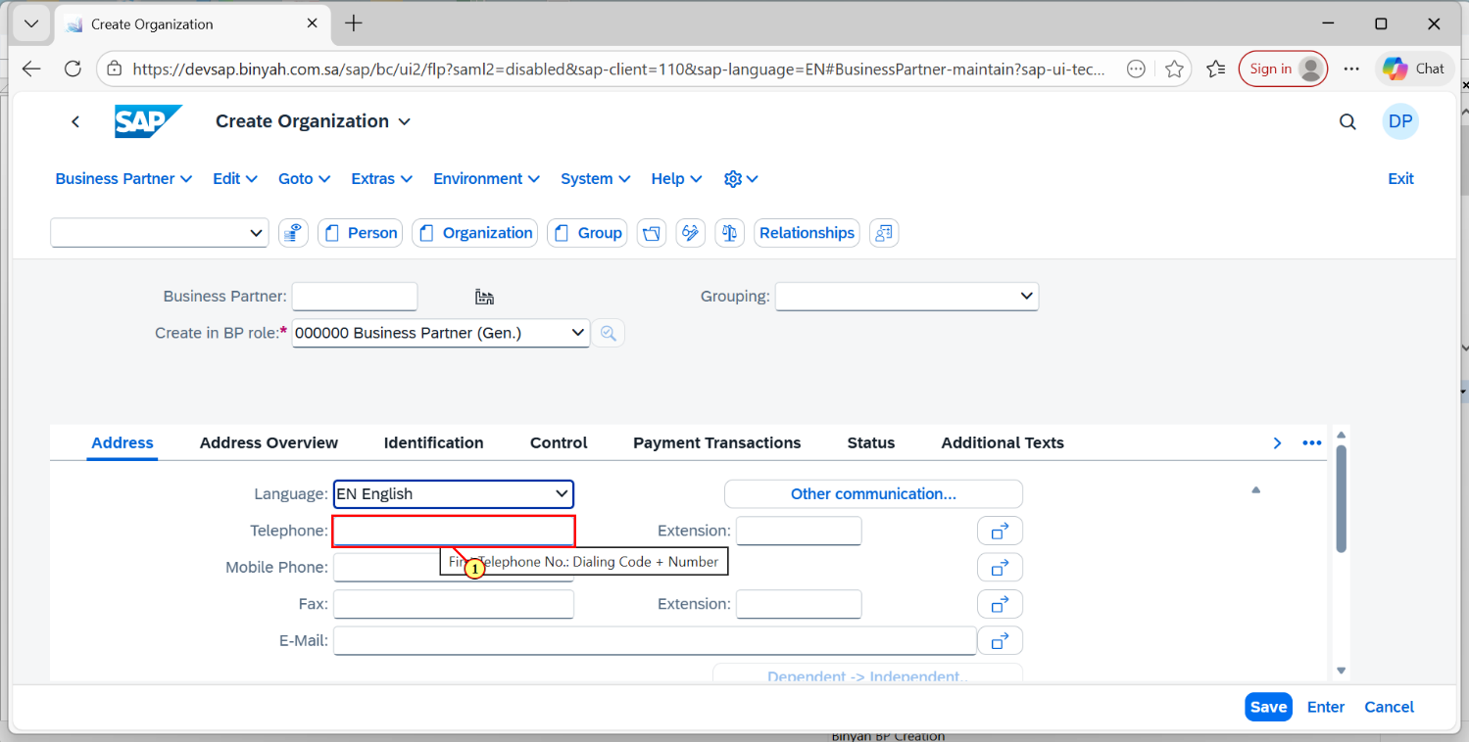

| Step | Action |
| --- | --- |
| (1) | Enter the Telephone Number in the given field. |

Create Organization - Personal - Microsoft​ Edge

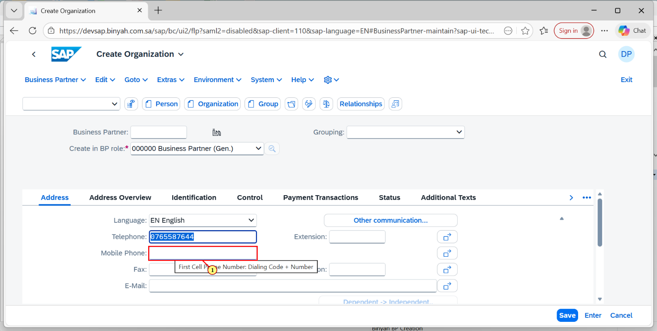

| Step | Action |
| --- | --- |
| (1) | Enter the Mobile Number in the given field. |

Create Organization - Personal - Microsoft​ Edge

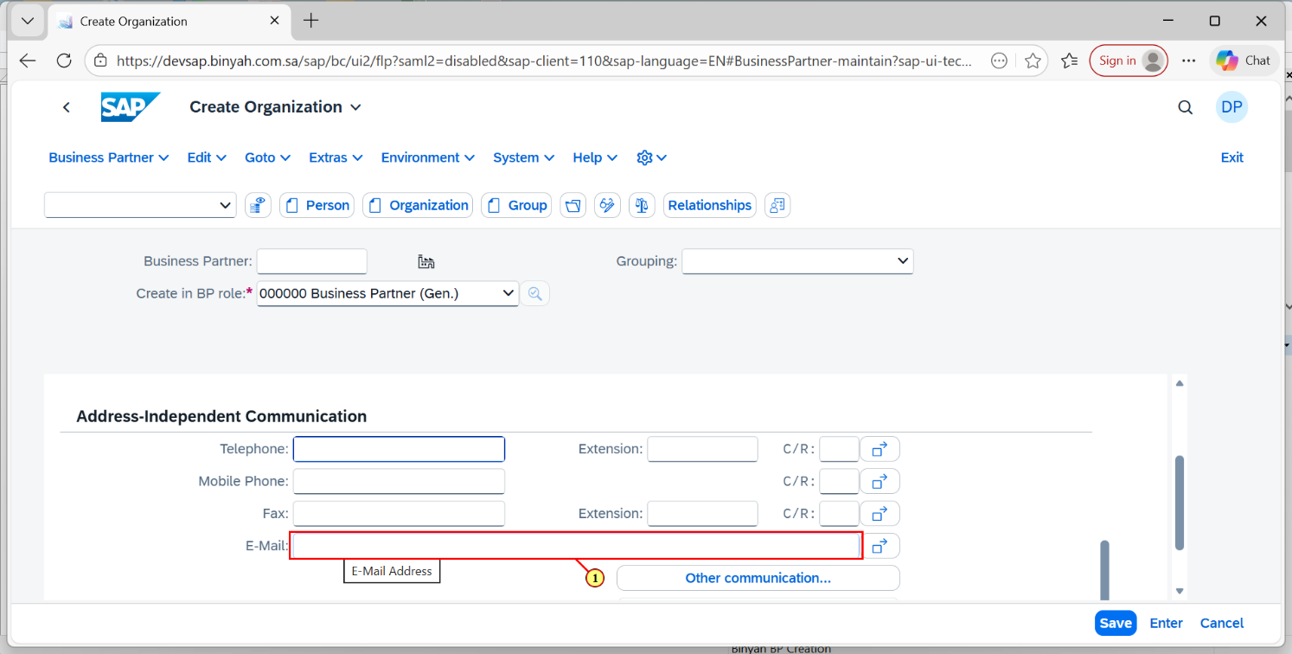

| Step | Action |
| --- | --- |
| (1) | Enter the E-Mail Id in the given field. |

Create Organization - Personal - Microsoft​ Edge

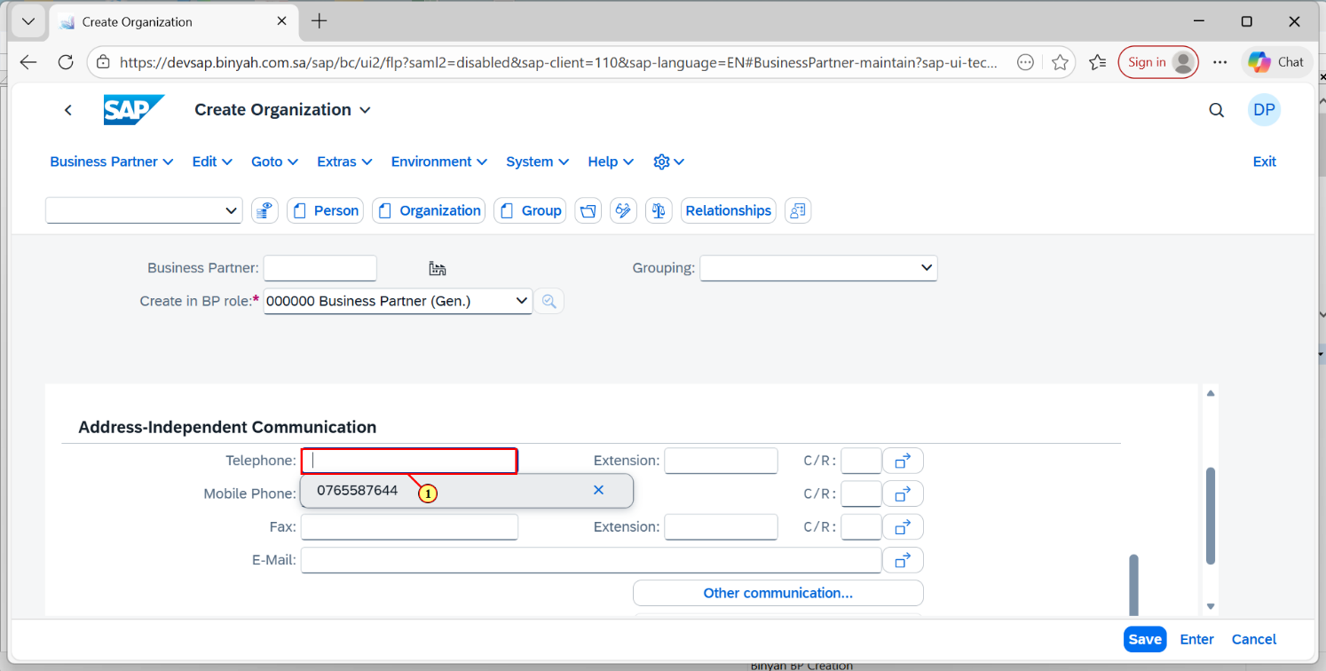

| Step | Action |
| --- | --- |
| (1) | Click on Telephone field and Enter the Number. |

Create Organization - Personal - Microsoft​ Edge

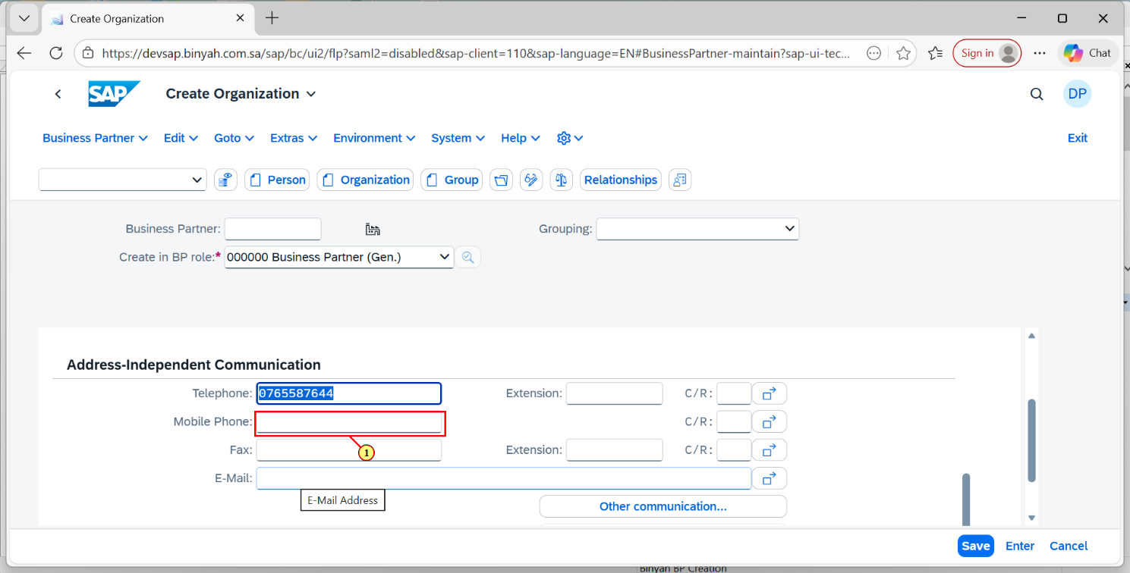

| Step | Action |
| --- | --- |
| (1) | Enter the Mobile Number in the field. |

Create Organization - Personal - Microsoft​ Edge

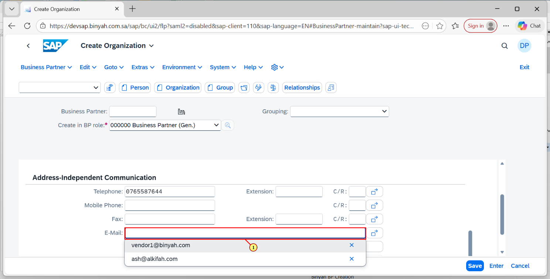

| Step | Action |
| --- | --- |
| (1) | Click on the E-Mail Id field and enter the respective E-Mail. |

Create Organization - Personal - Microsoft​ Edge

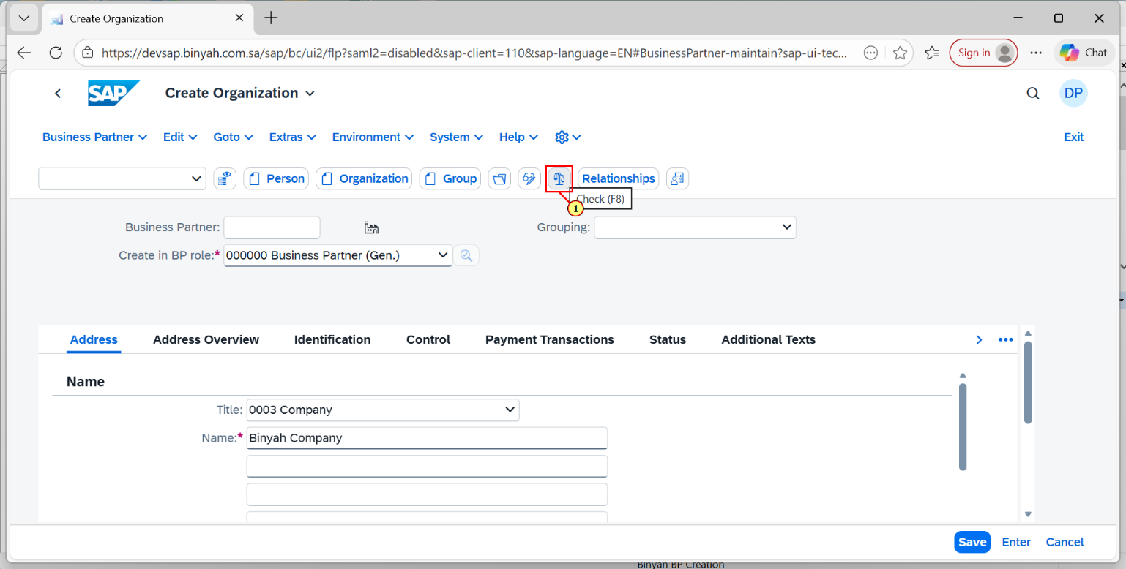

| Step | Action |
| --- | --- |
| (1) | After entering all the details. Click on "Check" and it will shows errors if exists else click on "Save" button. |

Create Organization - Personal - Microsoft​ Edge

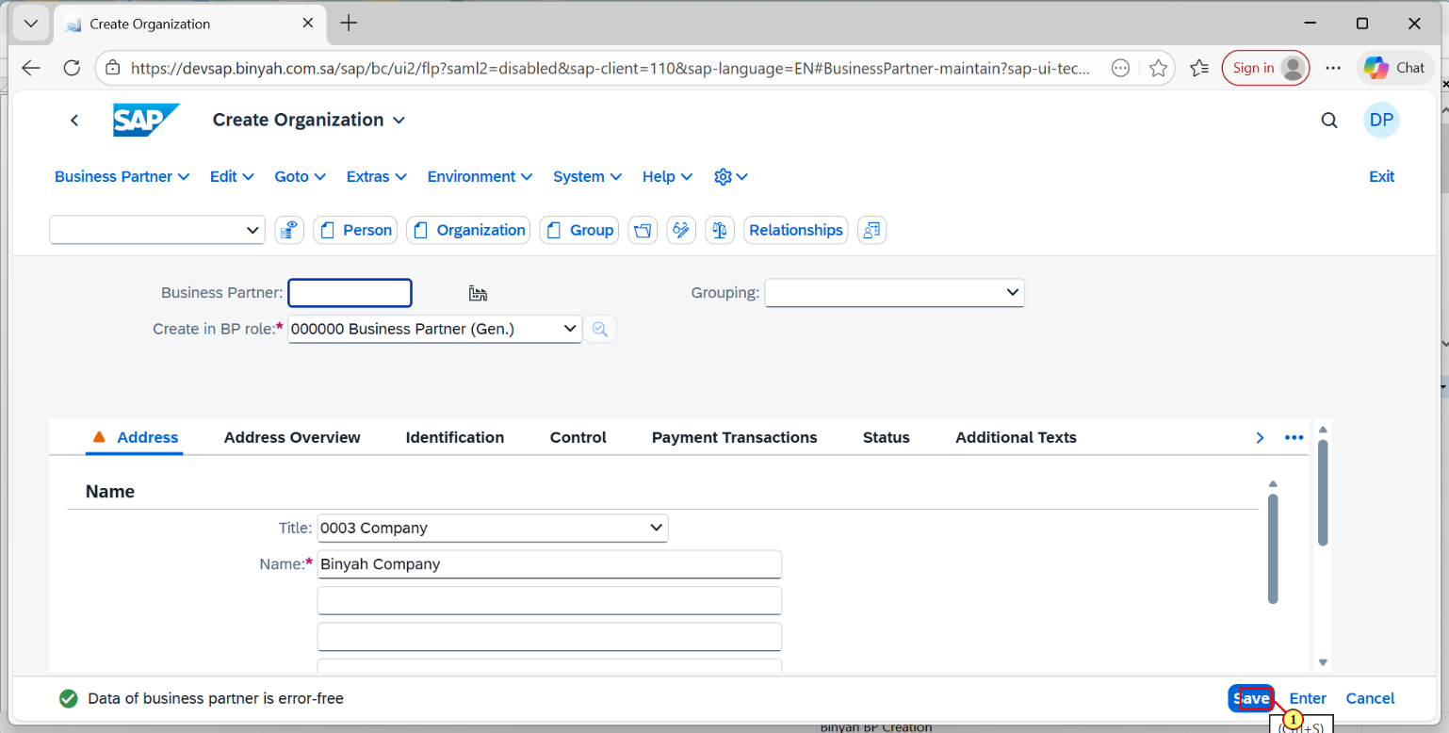

| Step | Action |
| --- | --- |
| (1) | After getting the pop-up "Business Partner is Error Free" Click on "Save". |

Display Organization : 11 - Personal - Microsoft​ Edge

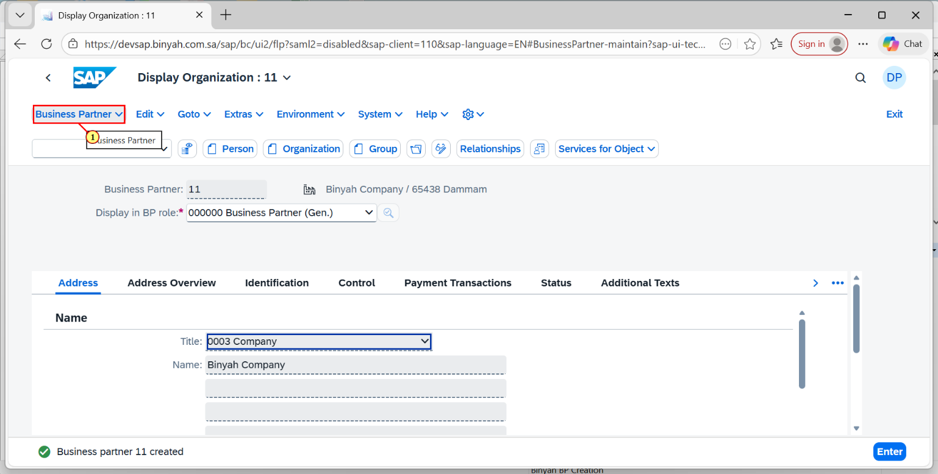

| Step | Action |
| --- | --- |
| (1) | Now click on Business Partner dropdown. |

Display Organization : 11 - Personal - Microsoft​ Edge

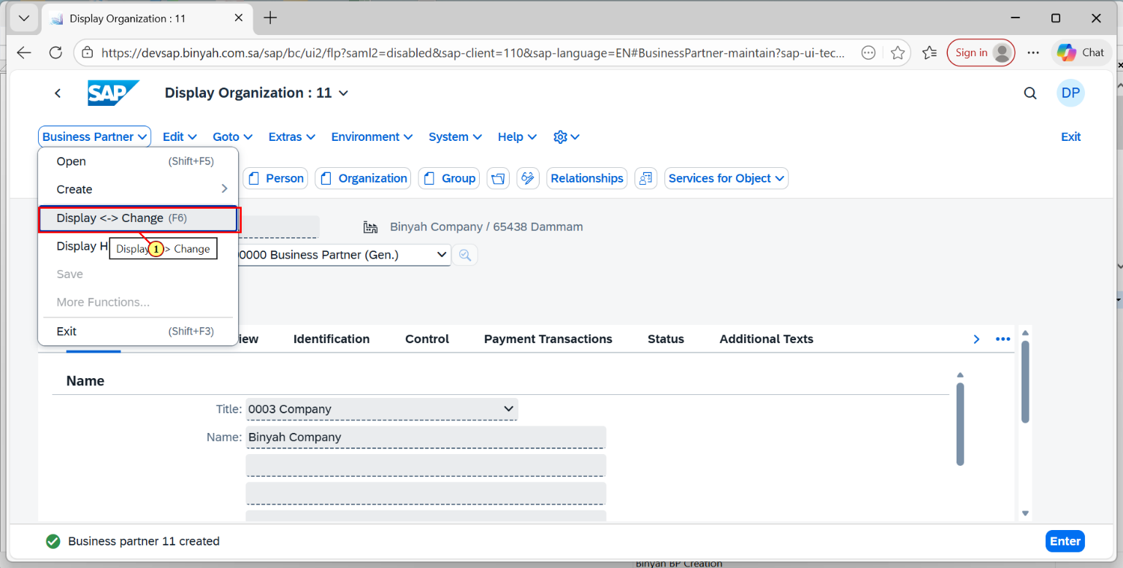

| Step | Action |
| --- | --- |
| (1) | Click on "Display <-> Change". |

Change Organization: 11 - Personal - Microsoft​ Edge

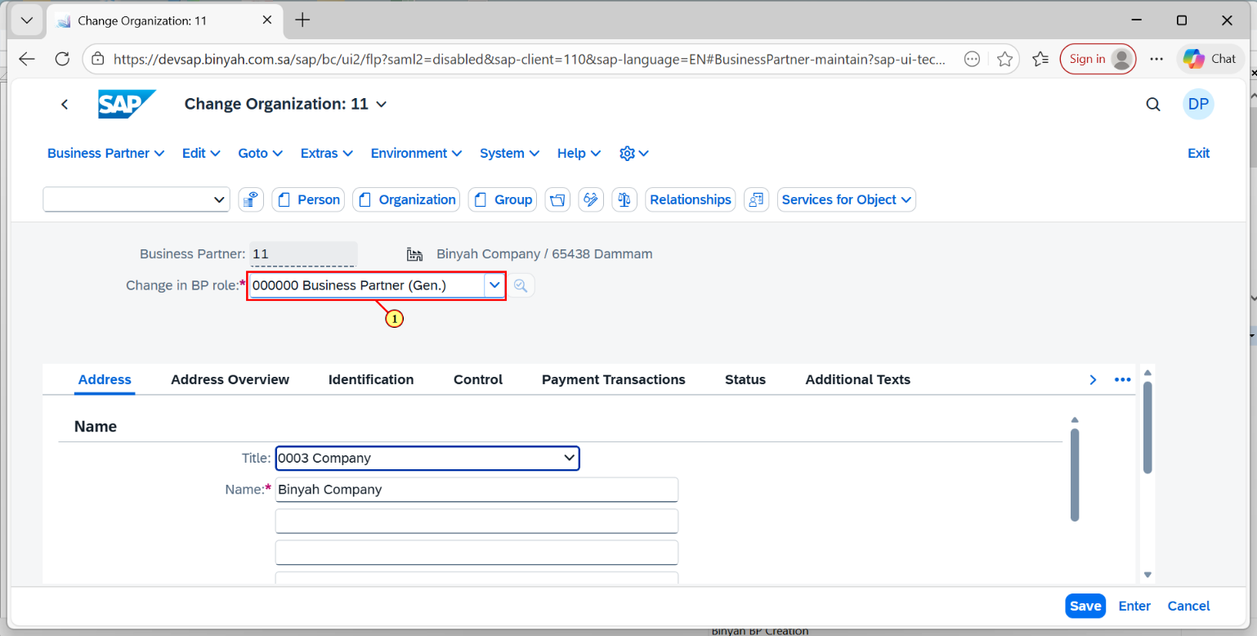

| Step | Action |
| --- | --- |
| (1) | Now in "Change in BP role field".Click on Dropdown menu |

Change Organization: 11 - Personal - Microsoft​ Edge

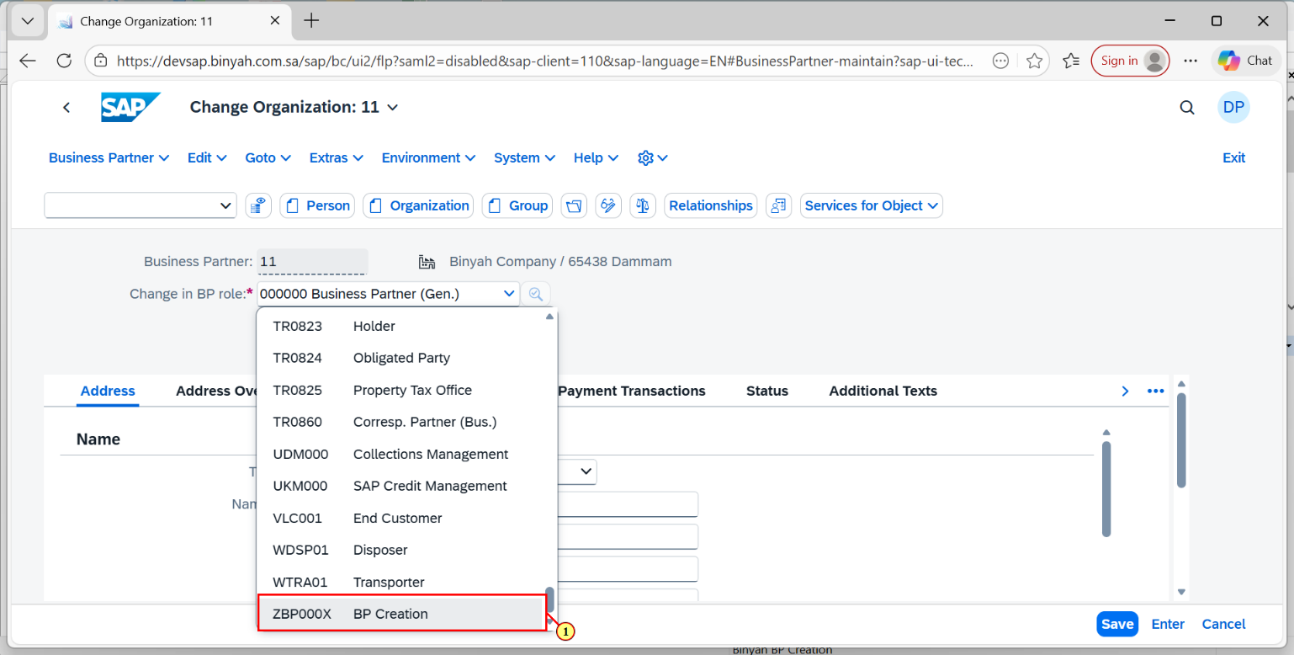

| Step | Action |
| --- | --- |
| (1) | Now Select ZBP000X option and Click "Enter". |

Change Organization: 11, new role BP Creation - Personal - Microsoft​ Edge

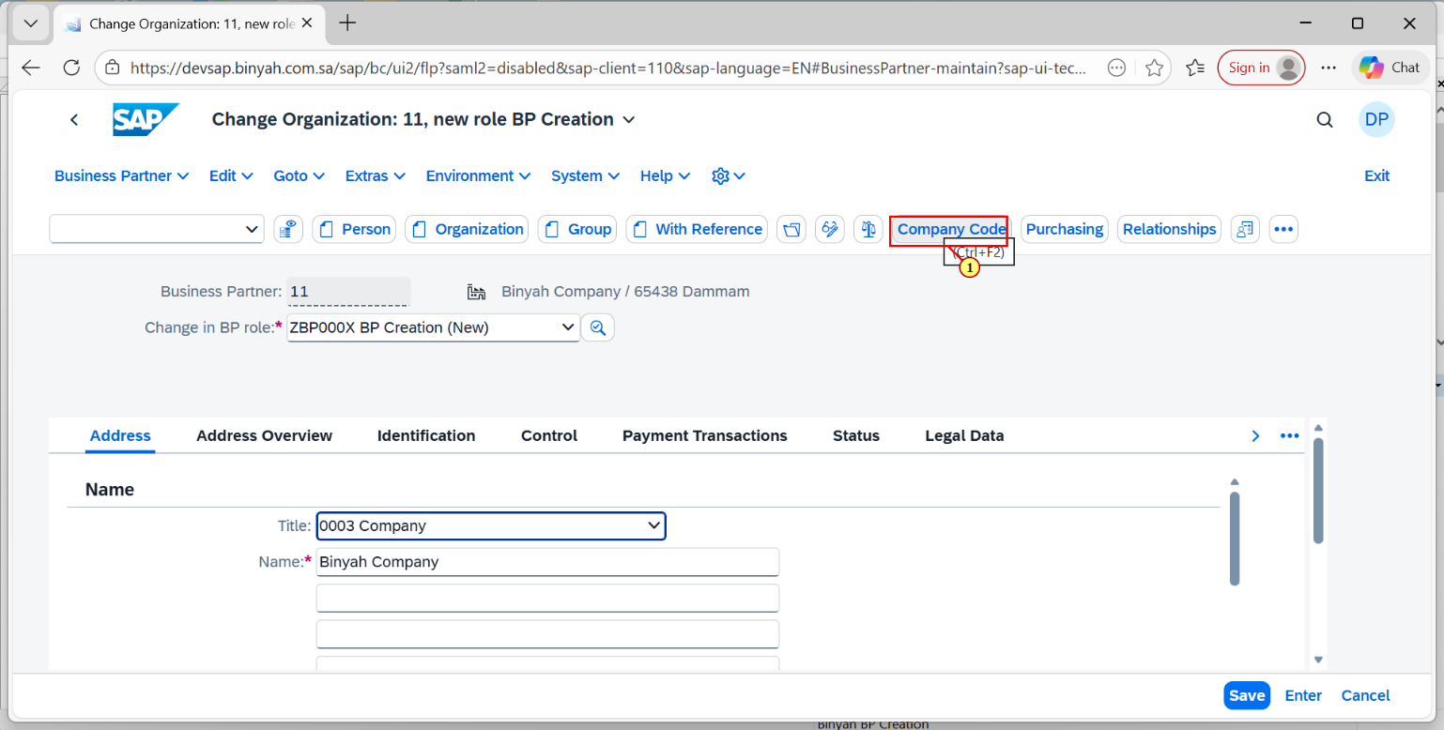

| Step | Action |
| --- | --- |
| (1) | Now click on "Company Code" to fill the Details below. |

Change Organization: 11, new role BP Creation - Personal - Microsoft​ Edge

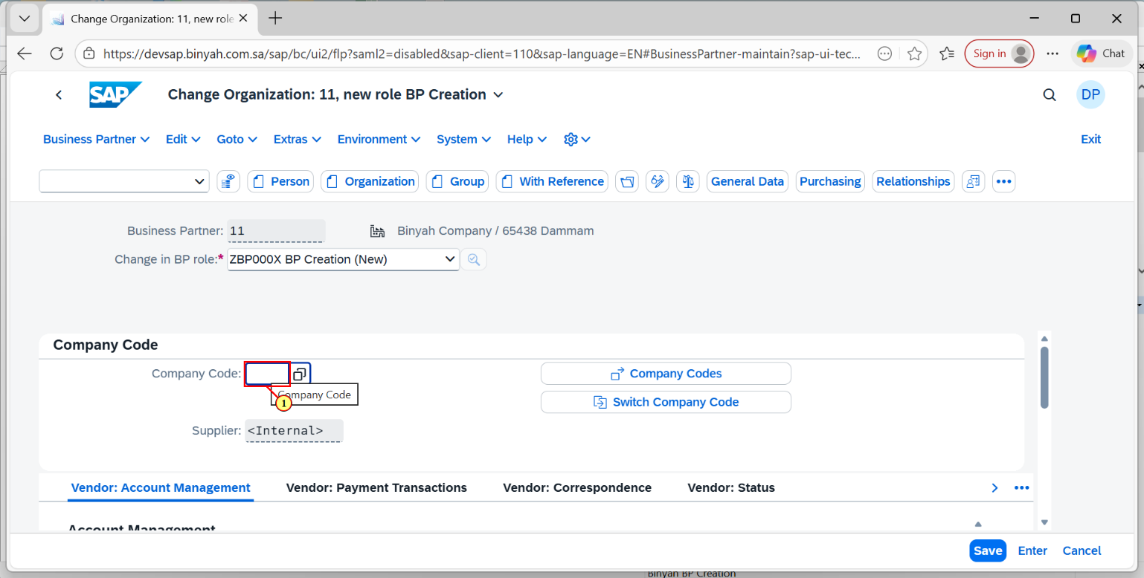

| Step | Action |
| --- | --- |
| (1) | Click On Company Code Search help. |

Change Organization: 11, new role BP Creation - Personal - Microsoft​ Edge

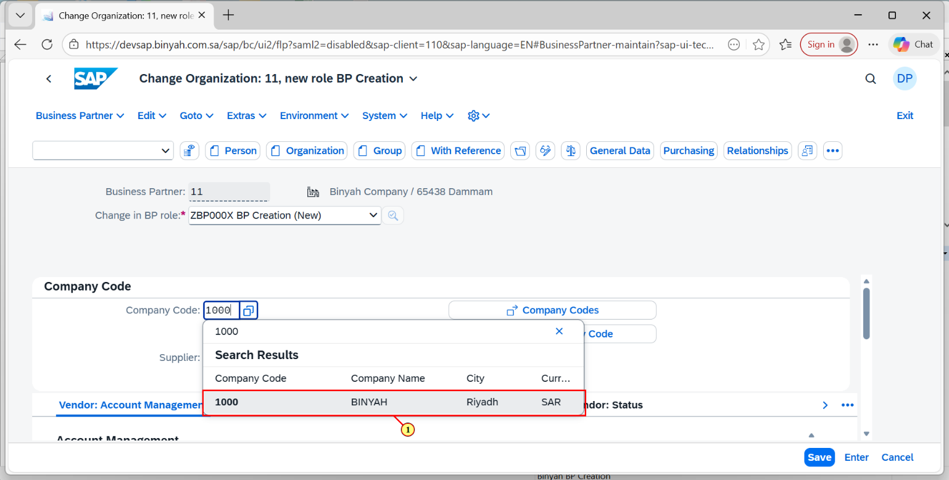

| Step | Action |
| --- | --- |
| (1) | Now select the Required plant and Press "Enter". |

Change Organization: 11, new role BP Creation - Personal - Microsoft​ Edge

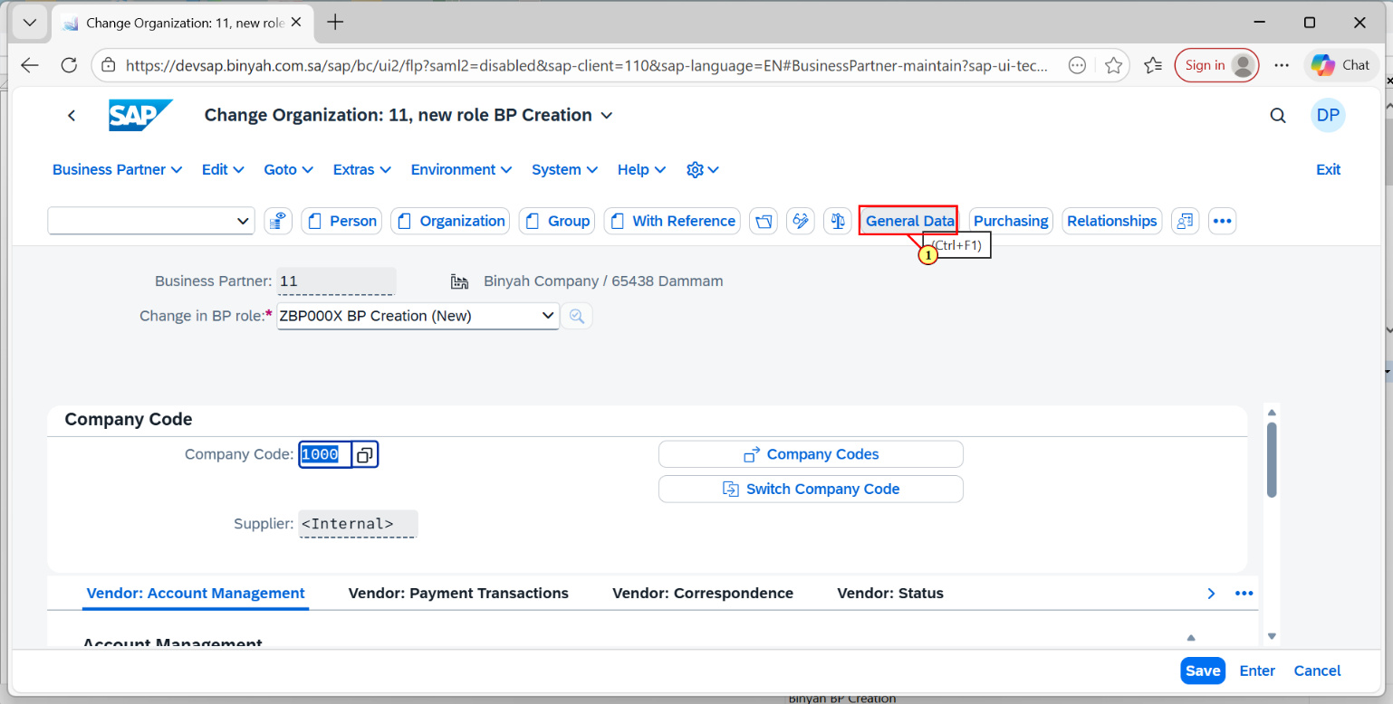

| Step | Action |
| --- | --- |
| (1) | Click on General Data and list of Details will be displayed down. |

Change Organization: 11, new role BP Creation - Personal - Microsoft​ Edge

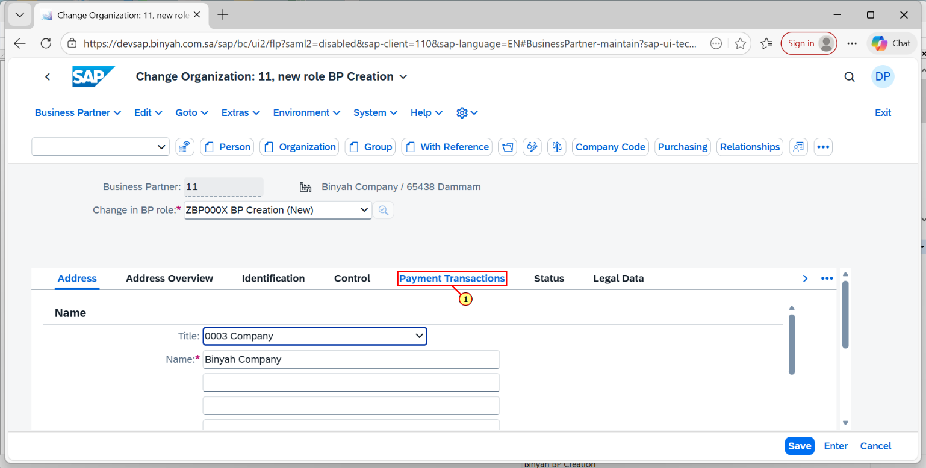

| Step | Action |
| --- | --- |
| (1) | Click On Payament Transaction Tab to fill out the bank details. |

Change Organization: 11, new role BP Creation - Personal - Microsoft​ Edge

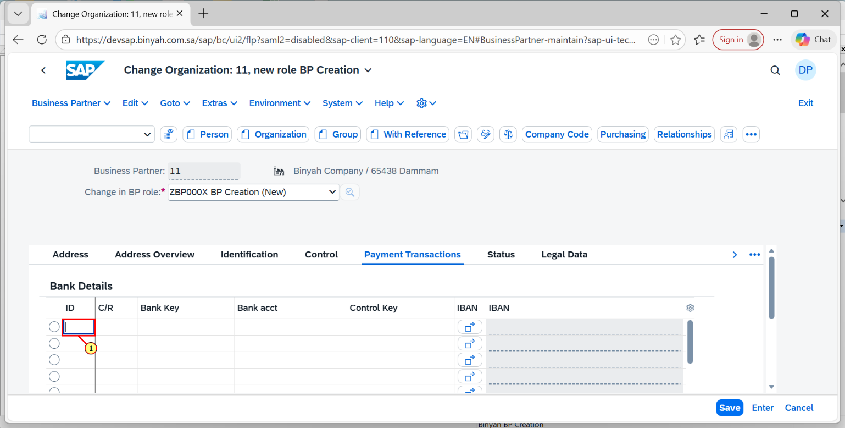

| Step | Action |
| --- | --- |
| (1) | Click On ID field and enter the BP's Bank ID. |

Change Organization: 11, new role BP Creation - Personal - Microsoft​ Edge

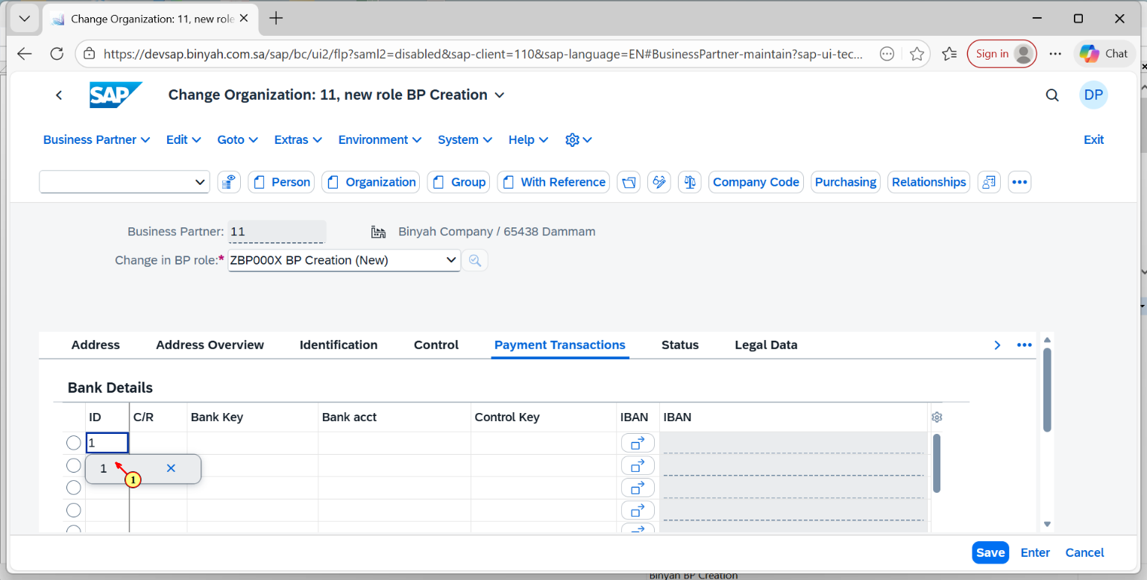

| Step | Action |
| --- | --- |
| (1) | After entering the ID in the field click "Enter". |

Change Organization: 11, new role BP Creation - Personal - Microsoft​ Edge

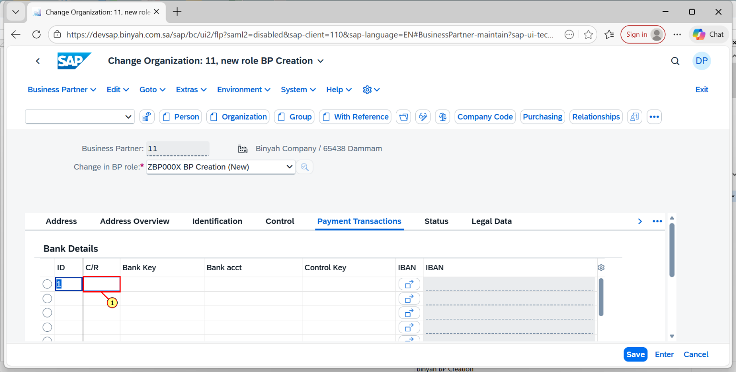

| Step | Action |
| --- | --- |
| (1) | Click on C/R field. |

Change Organization: 11, new role BP Creation - Personal - Microsoft​ Edge

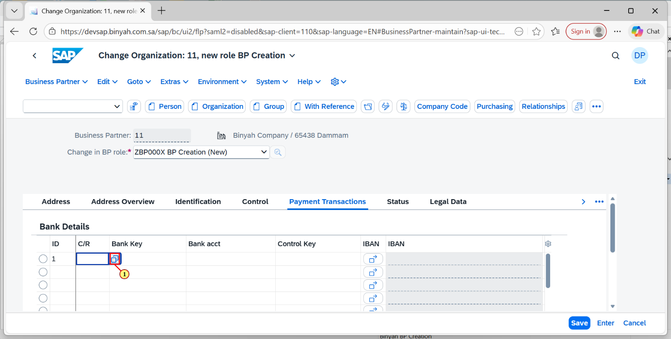

| Step | Action |
| --- | --- |
| (1) | Click on Country/Region search help to get the respective term. |

Change Organization: 11, new role BP Creation - Personal - Microsoft​ Edge

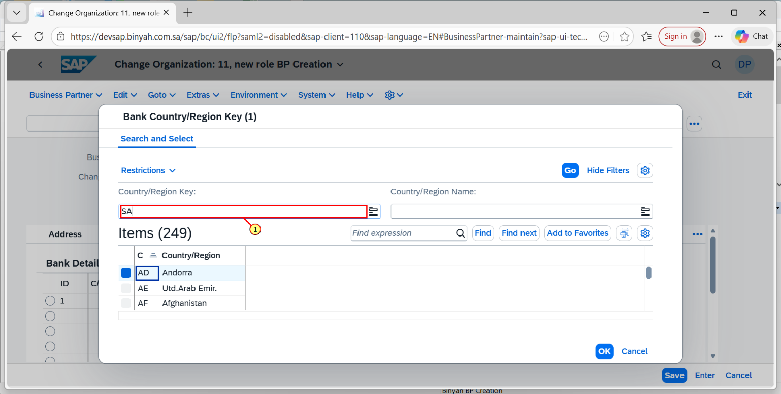

| Step | Action |
| --- | --- |
| (1) | After clickiing the search help it will navigate to this page. now in this field enter the search term of the country. |

Change Organization: 11, new role BP Creation - Personal - Microsoft​ Edge

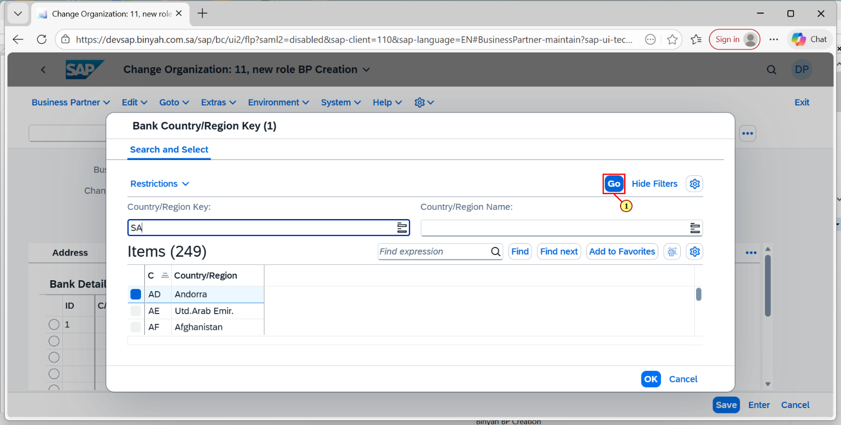

| Step | Action |
| --- | --- |
| (1) | Now press "GO" button. |

Change Organization: 11, new role BP Creation - Personal - Microsoft​ Edge

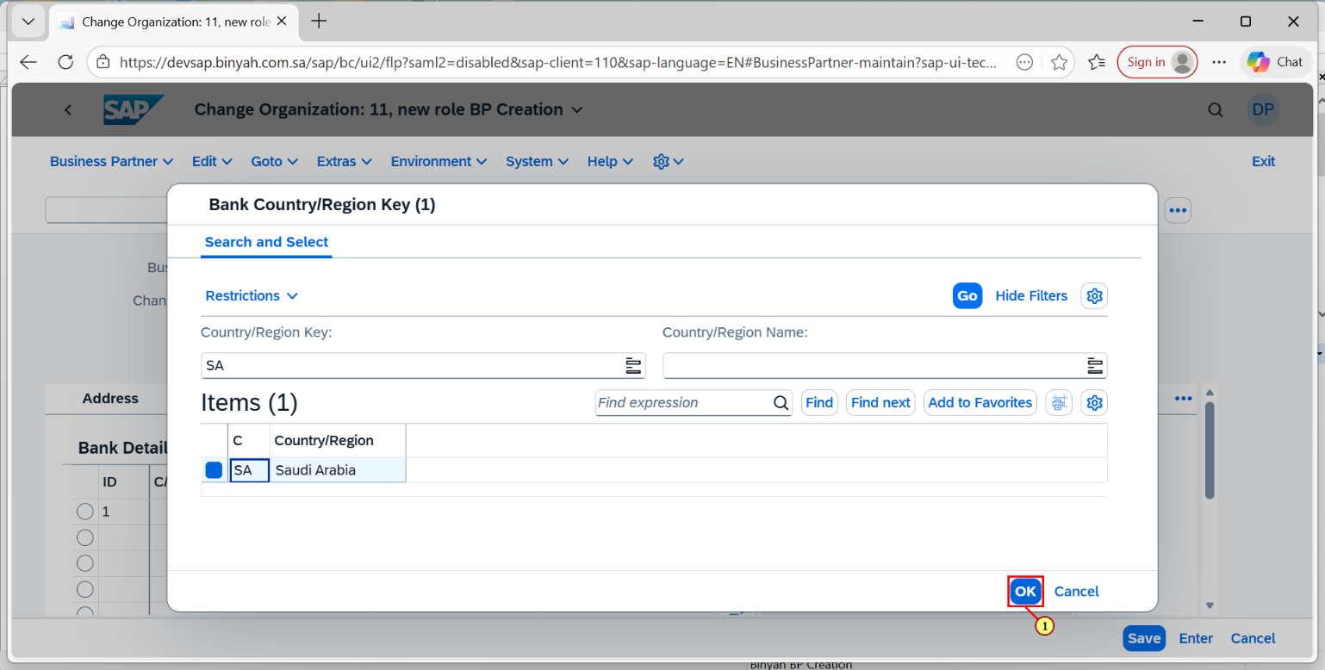

| Step | Action |
| --- | --- |
| (1) | Selecting the Required country click on "OK". |

Change Organization: 11, new role BP Creation - Personal - Microsoft​ Edge

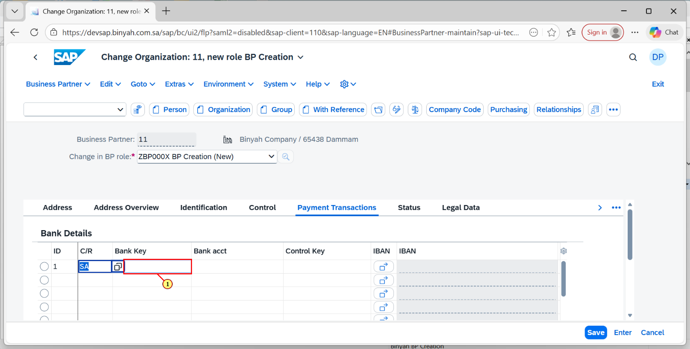

| Step | Action |
| --- | --- |
| (1) | Moving on to Bank key Tab, Click on search help. |

Change Organization: 11, new role BP Creation - Personal - Microsoft​ Edge

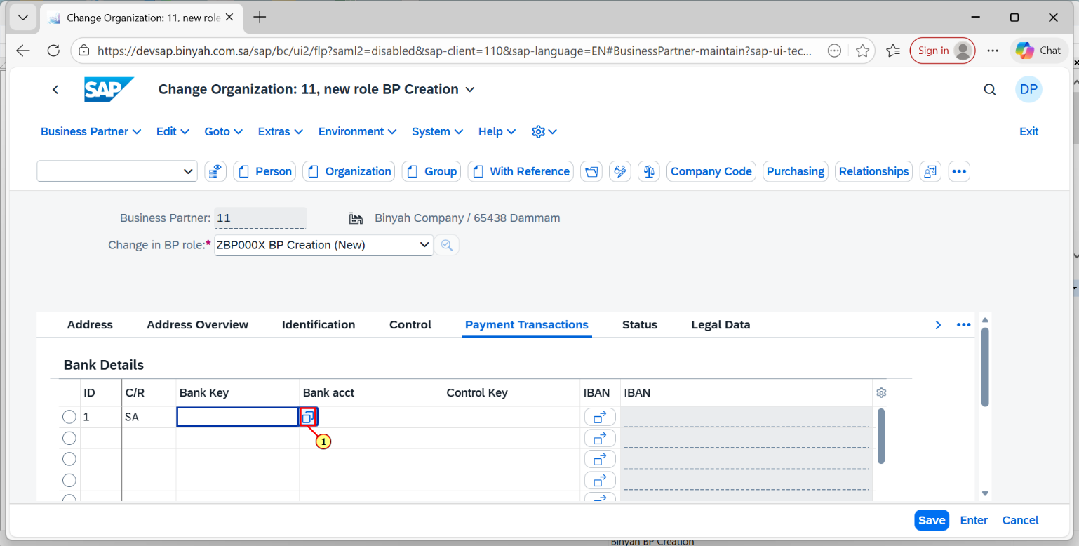

| Step | Action |
| --- | --- |
| (1) | Click on search help icon. |

Change Organization: 11, new role BP Creation - Personal - Microsoft​ Edge

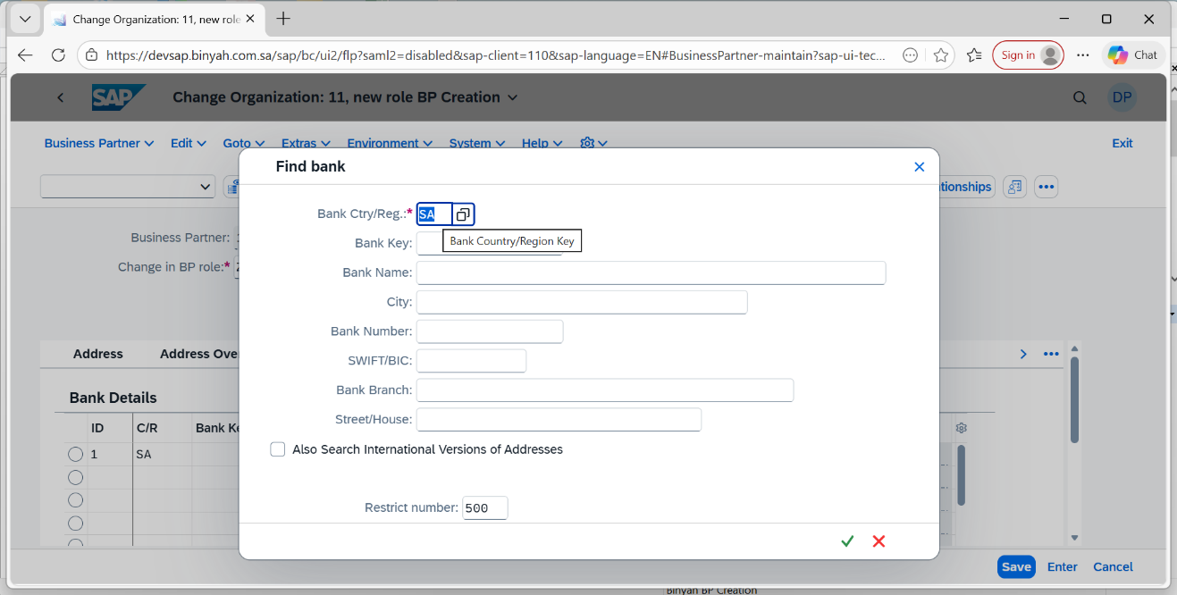

| Step | Action |
| --- | --- |
|  | **By entering the Bank ctry/Reg with Country and press "Enter".You can able to see a list of keys.** |

Change Organization: 11, new role BP Creation - Personal - Microsoft​ Edge

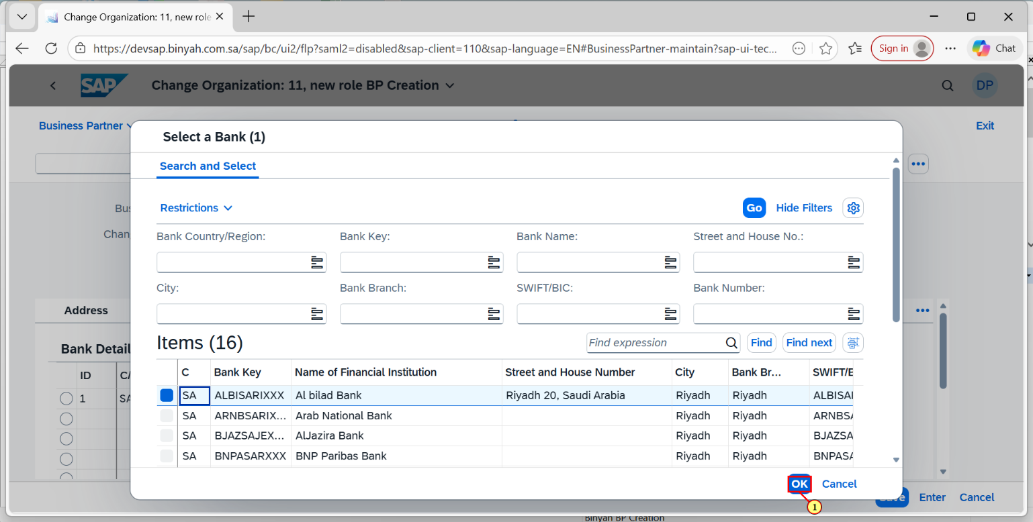

| Step | Action |
| --- | --- |
| (1) | After choosing on among these and click on "OK". |

Change Organization: 11, new role BP Creation - Personal - Microsoft​ Edge

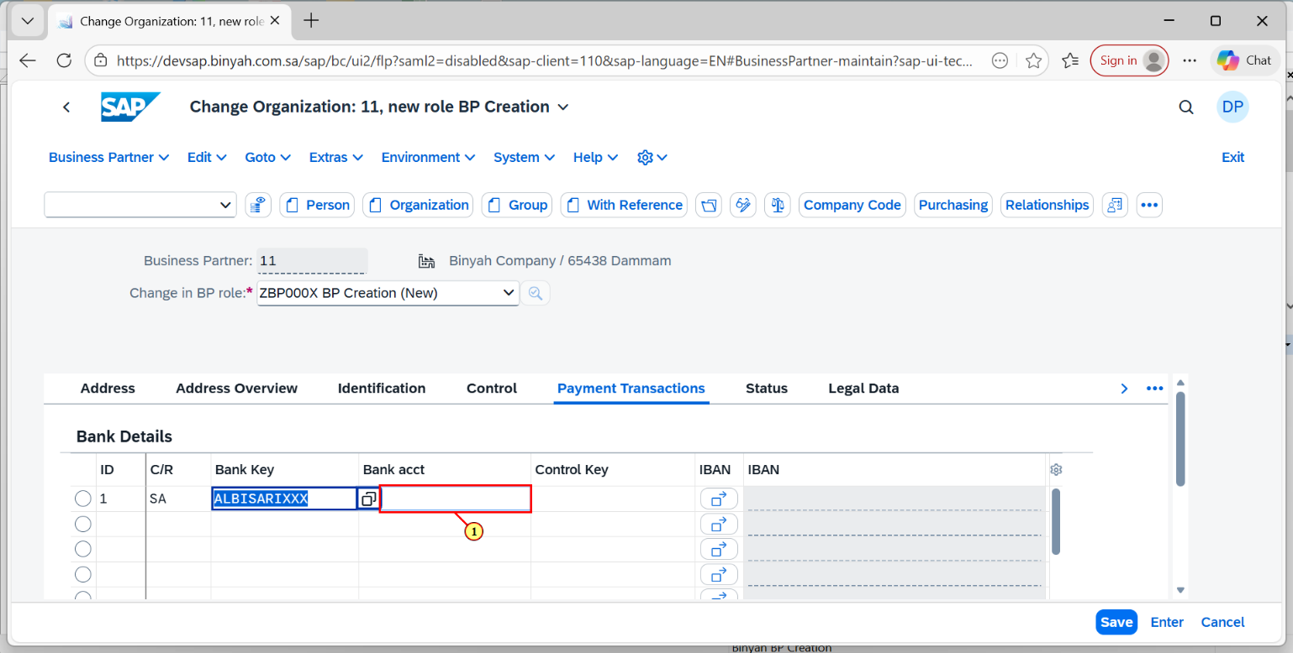

| Step | Action |
| --- | --- |
| (1) | Now enter the Bank Account Number in the given field. |

Change Organization: 11, new role BP Creation - Personal - Microsoft​ Edge

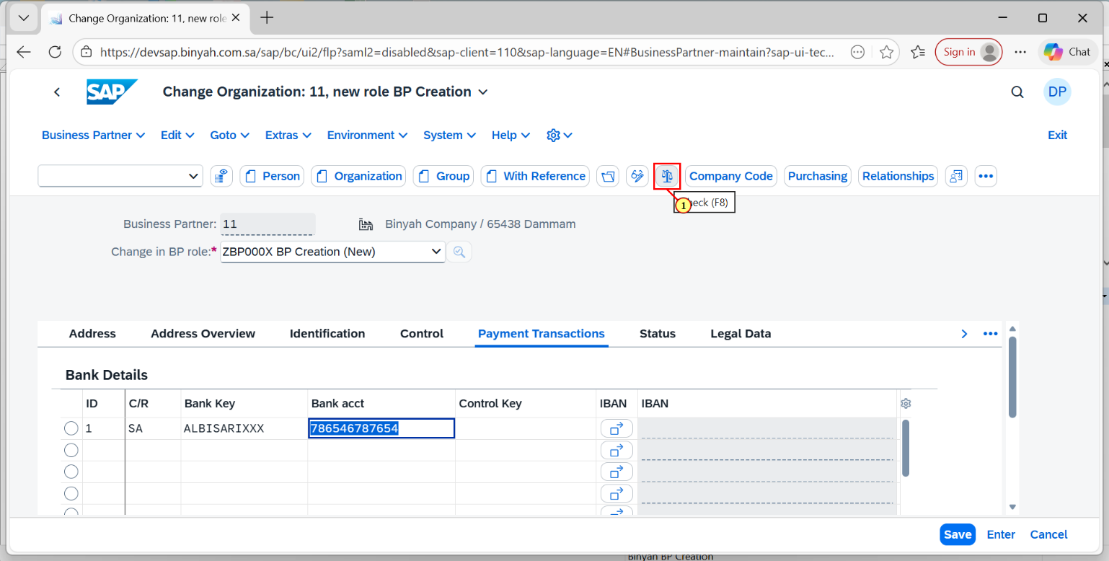

| Step | Action |
| --- | --- |
| (1) | After entering all the details mentioned above. Click on "CHECK" to check errors. |

Change Organization: 11, new role BP Creation - Personal - Microsoft​ Edge

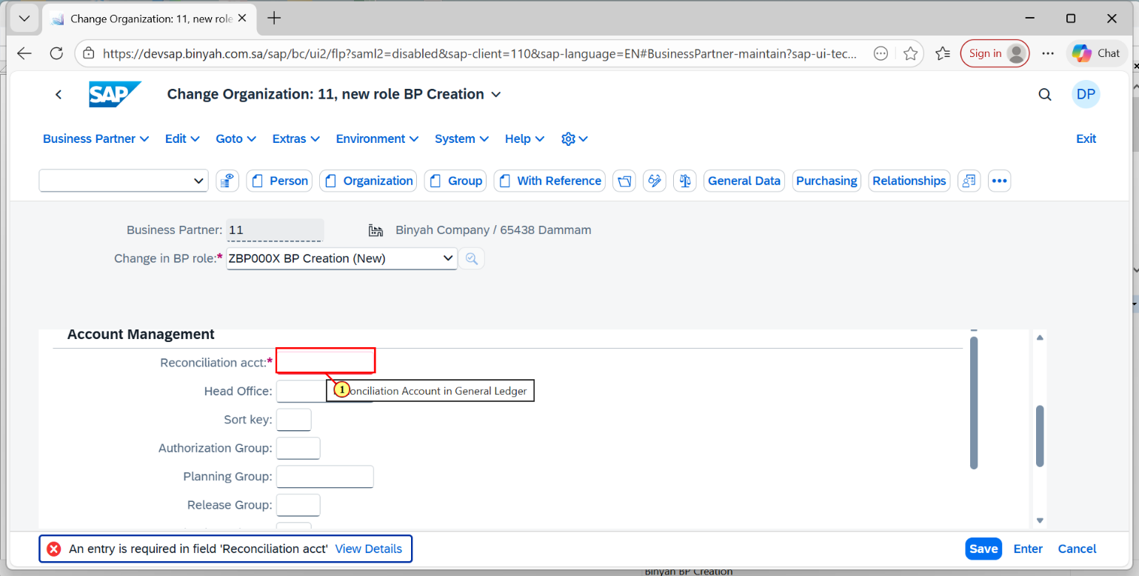

| Step | Action |
| --- | --- |
| (1) | Now moving to company code. Click on Account Management Tab and Enter the Reconcilation account in the field. |

Change Organization: 11, new role BP Creation - Personal - Microsoft​ Edge

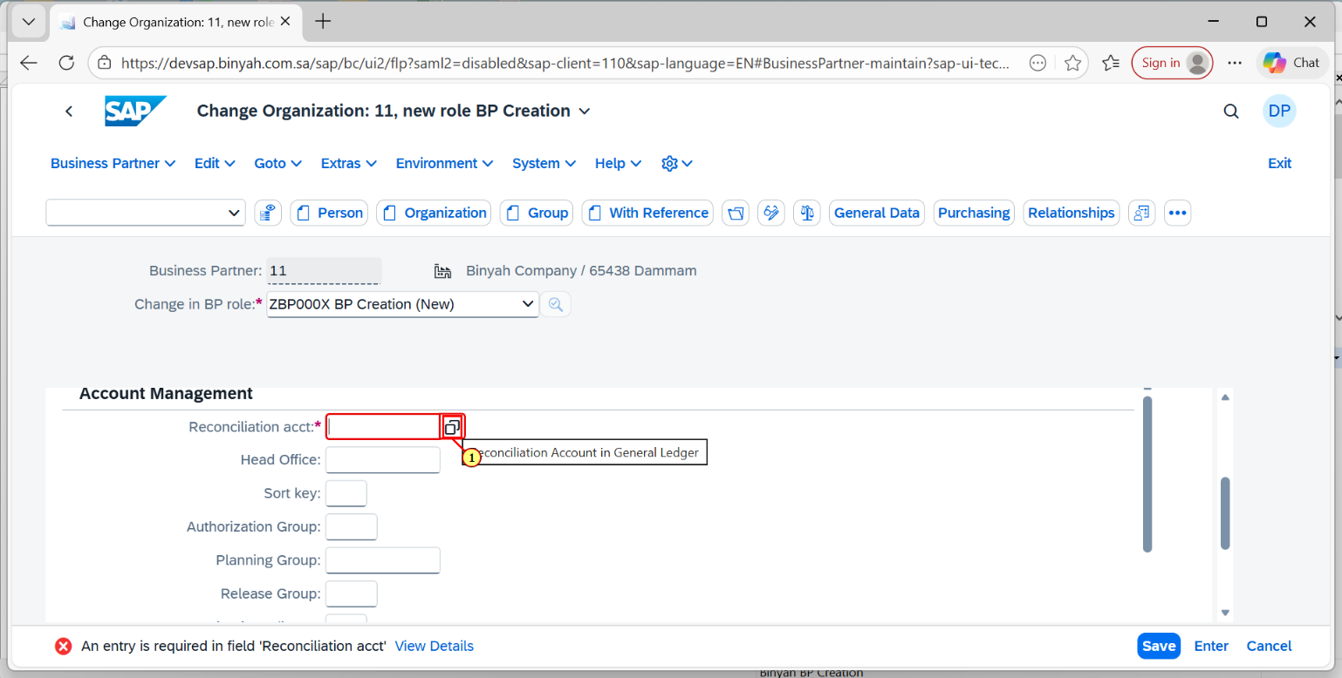

| Step | Action |
| --- | --- |
| (1) | Click on Search term and choose the required Reconciliation ccount and press " Enter". |

Change Organization: 11, new role BP Creation - Personal - Microsoft​ Edge

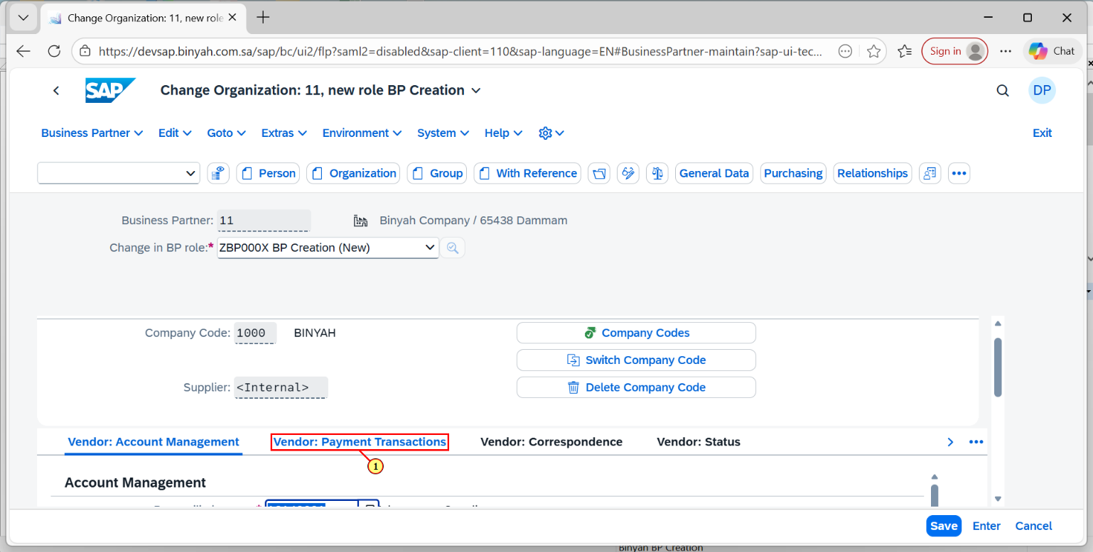

| Step | Action |
| --- | --- |
| (1) | Click on Vendor:Payment Transaction tab fill the details below. |

Change Organization: 11, new role BP Creation - Personal - Microsoft​ Edge

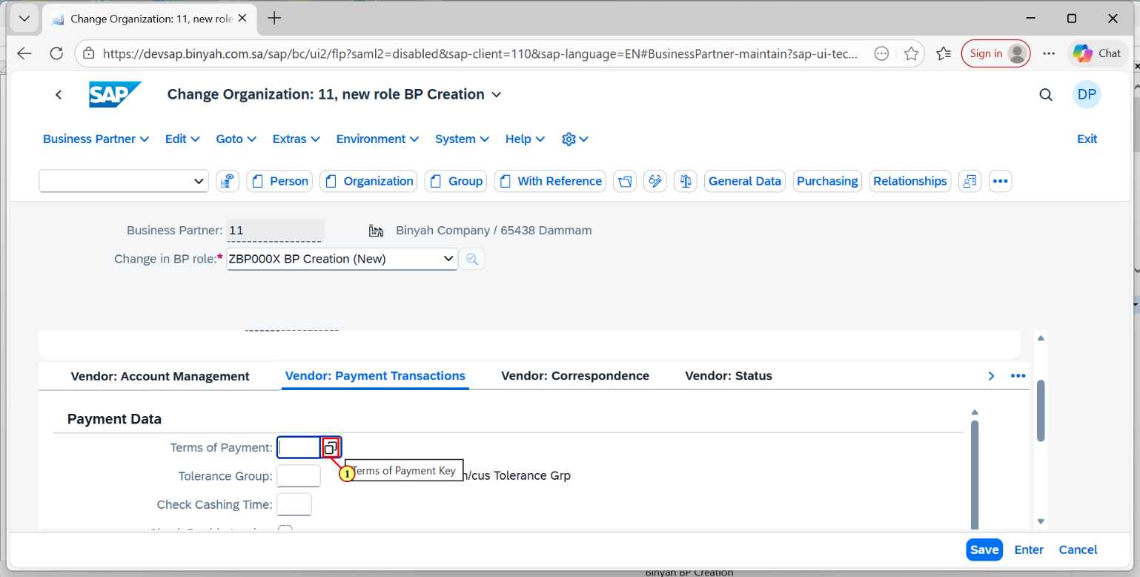

| Step | Action |
| --- | --- |
| (1) | Click on Search help icon. |

Change Organization: 11, new role BP Creation - Personal - Microsoft​ Edge

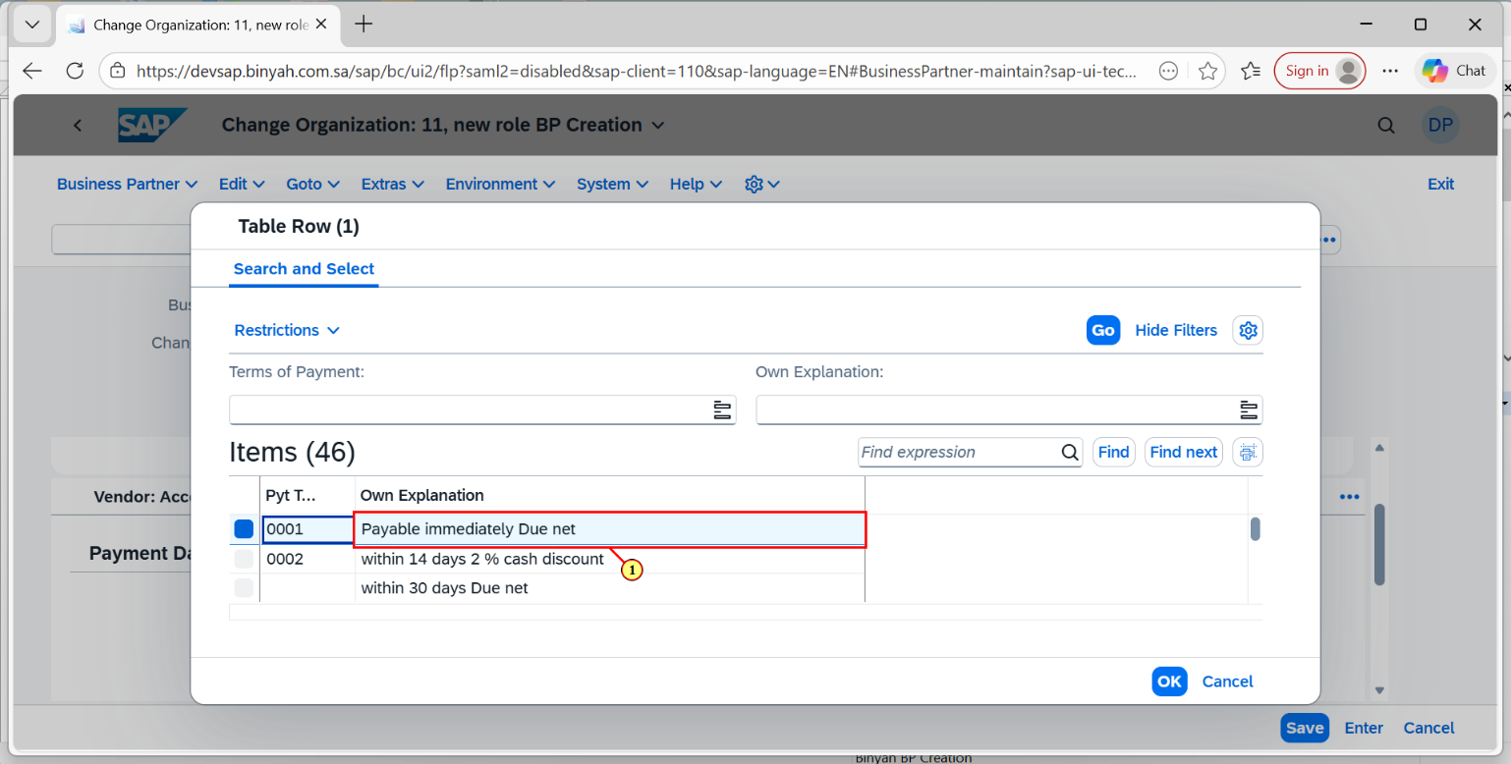

| Step | Action |
| --- | --- |
| (1) | After clicking the search help icon the page is navigated. Now choose the payment terms. |

Change Organization: 11, new role BP Creation - Personal - Microsoft​ Edge

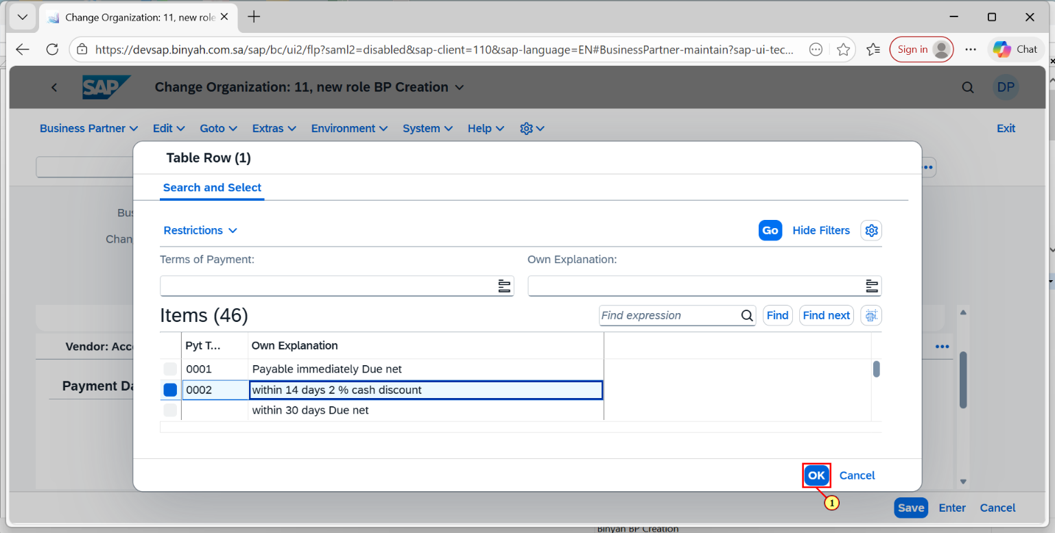

| Step | Action |
| --- | --- |
| (1) | After choosing the payment term Click on "OK". |

Change Organization: 11, new role BP Creation - Personal - Microsoft​ Edge

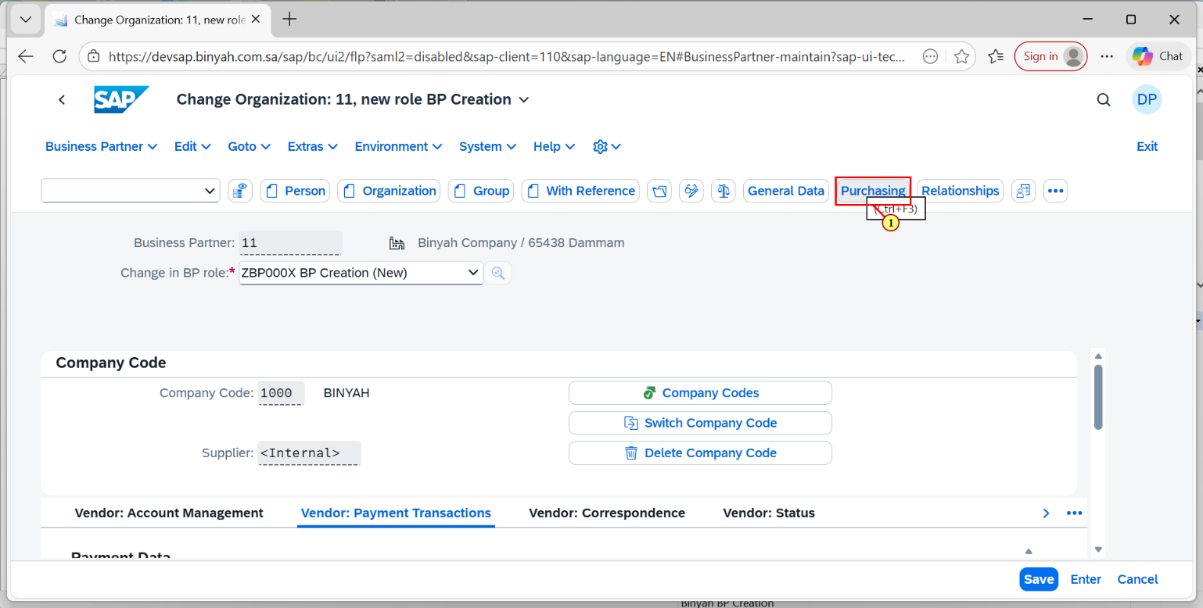

| Step | Action |
| --- | --- |
| (1) | Now click on "Purchasing" to fill all the details in purchasing part. |

Change Organization: 11, new role BP Creation - Personal - Microsoft​ Edge

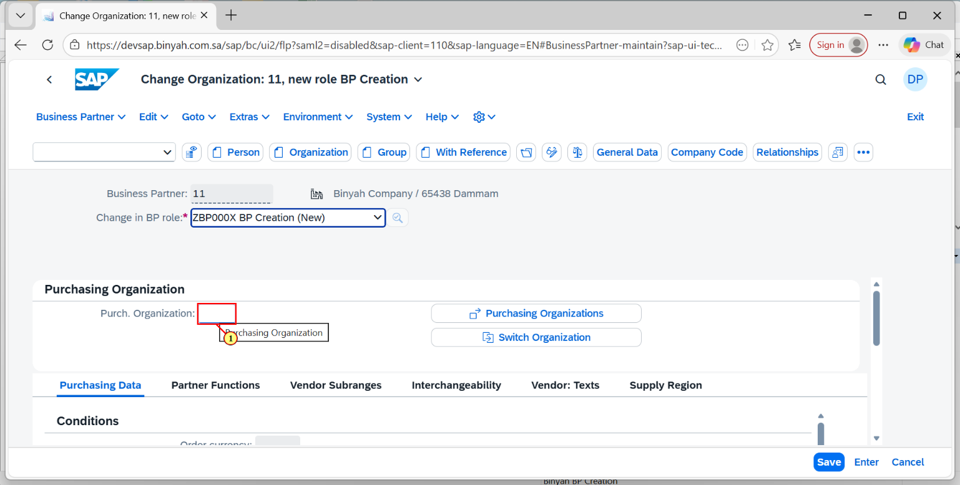

| Step | Action |
| --- | --- |
| (1) | Click on the Purchase Organization Search help. |

Change Organization: 11, new role BP Creation - Personal - Microsoft​ Edge

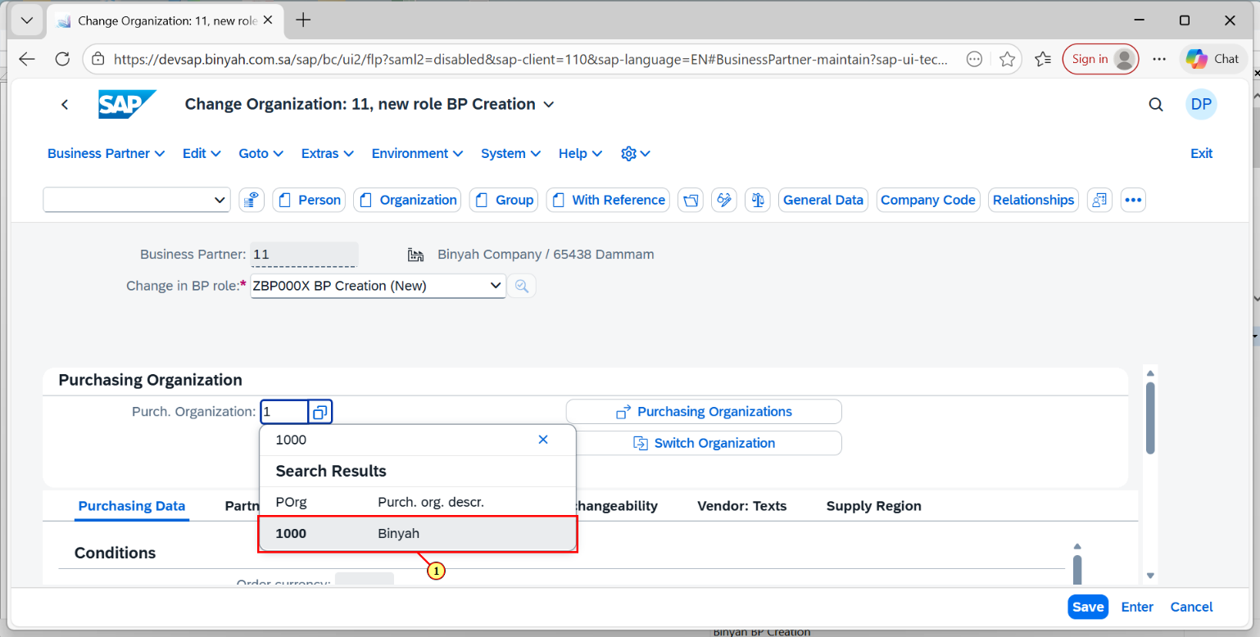

| Step | Action |
| --- | --- |
| (1) | After clicking the search help select the required purchase organization and click "Enter". |

Change Organization: 11, new role BP Creation - Personal - Microsoft​ Edge

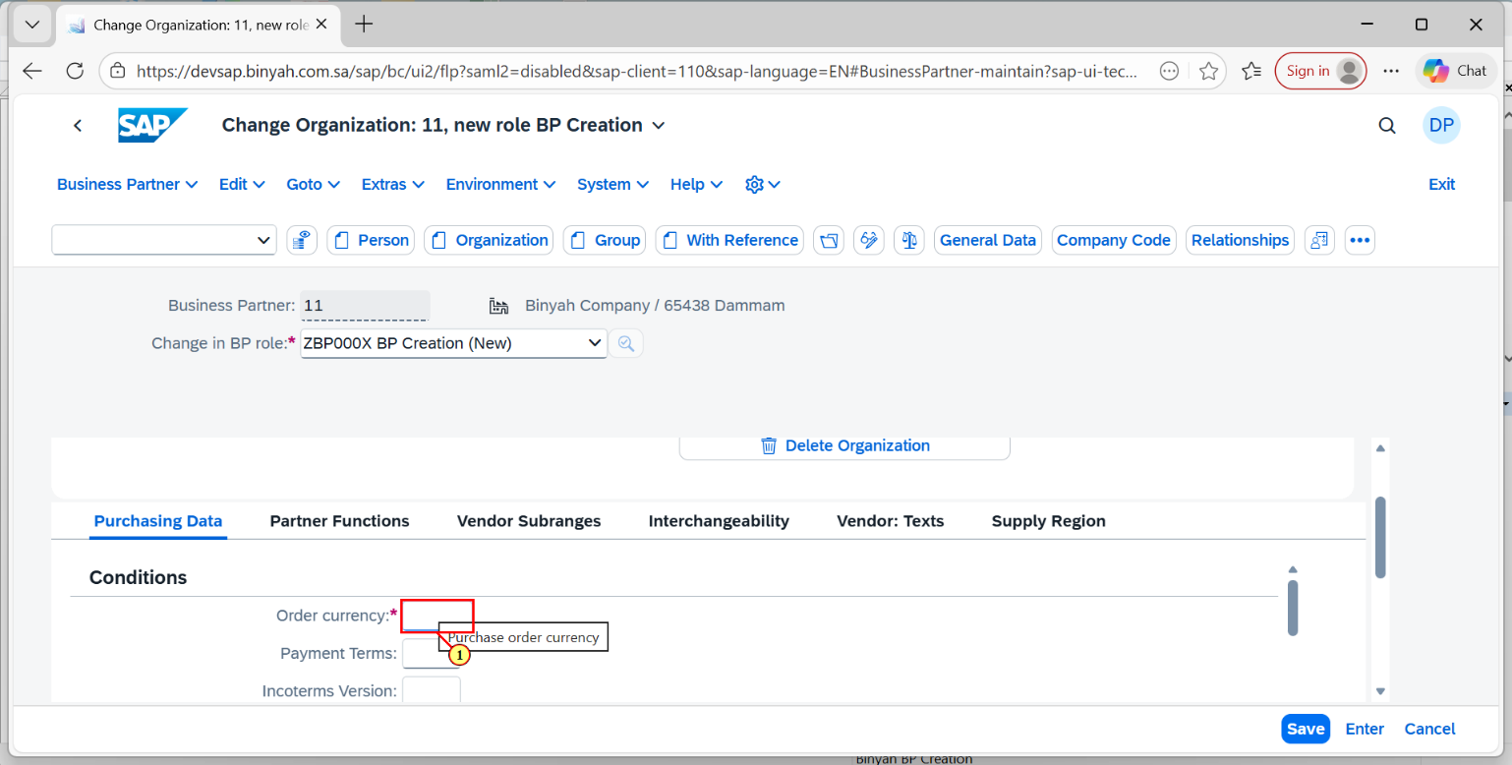

| Step | Action |
| --- | --- |
| (1) | Now we need to enter the order currency in the tab. |

Change Organization: 11, new role BP Creation - Personal - Microsoft​ Edge

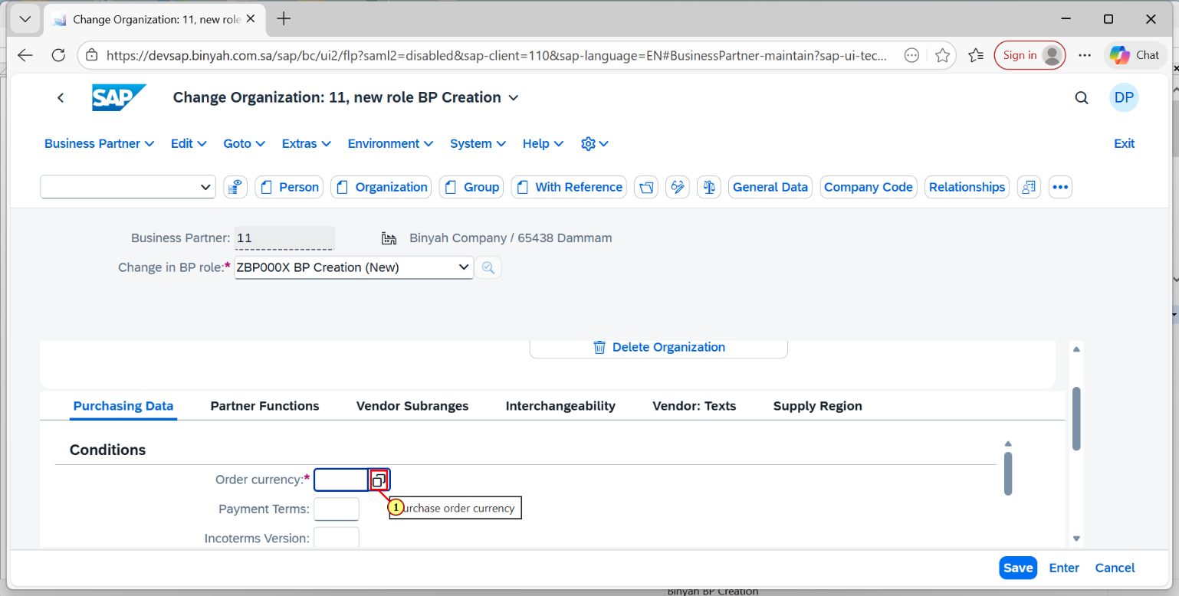

| Step | Action |
| --- | --- |
| (1) | Click on Order Currency Search help. |

Change Organization: 11, new role BP Creation - Personal - Microsoft​ Edge

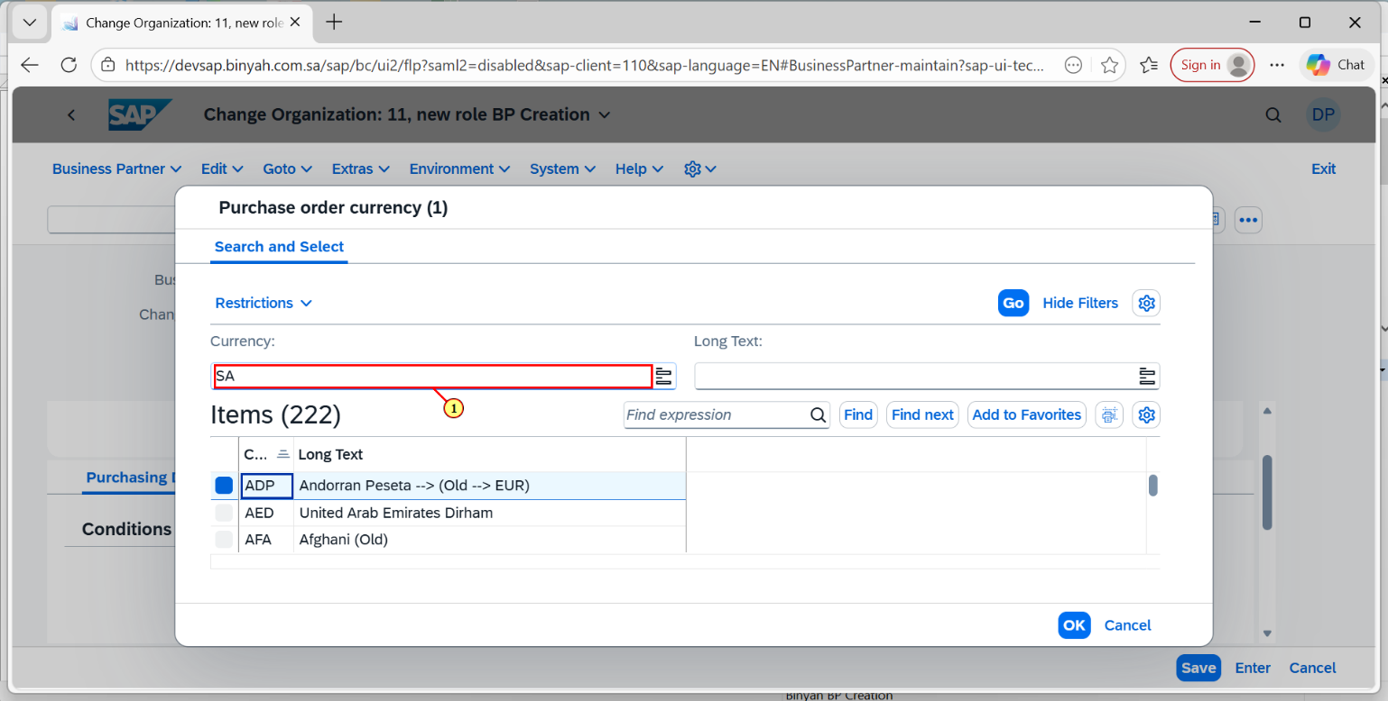

| Step | Action |
| --- | --- |
| (1) | After clicking the search help it will navigate to this page.Here you need to enter the search help terms. |

Change Organization: 11, new role BP Creation - Personal - Microsoft​ Edge

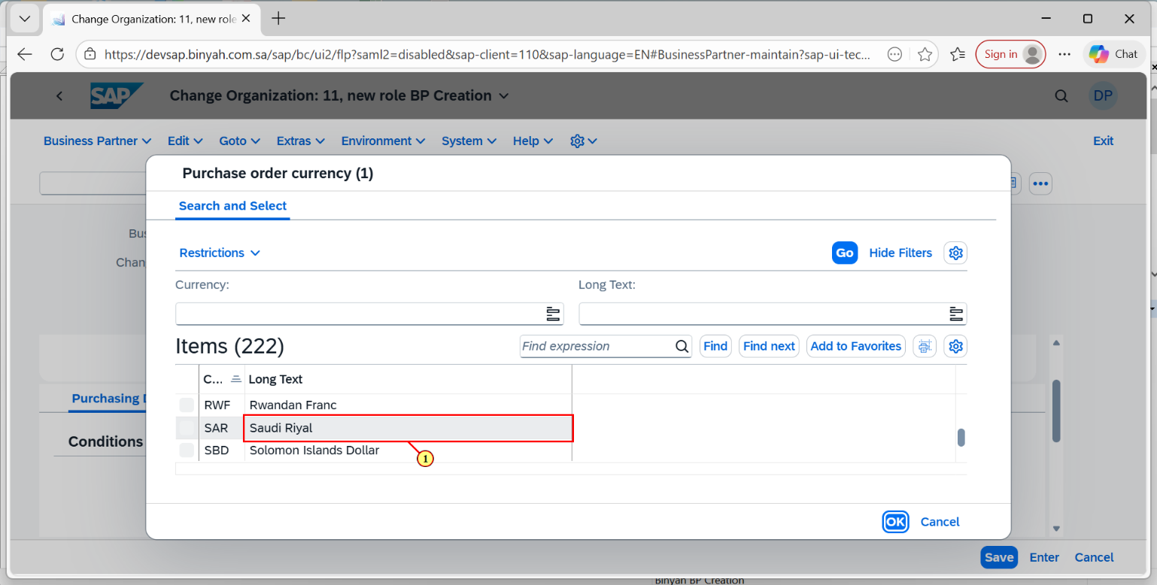

| Step | Action |
| --- | --- |
| (1) | **Select the Currency and click on "OK".** |

### **Change Organization: 11, new role BP Creation - Personal - Microsoft​ Edge**

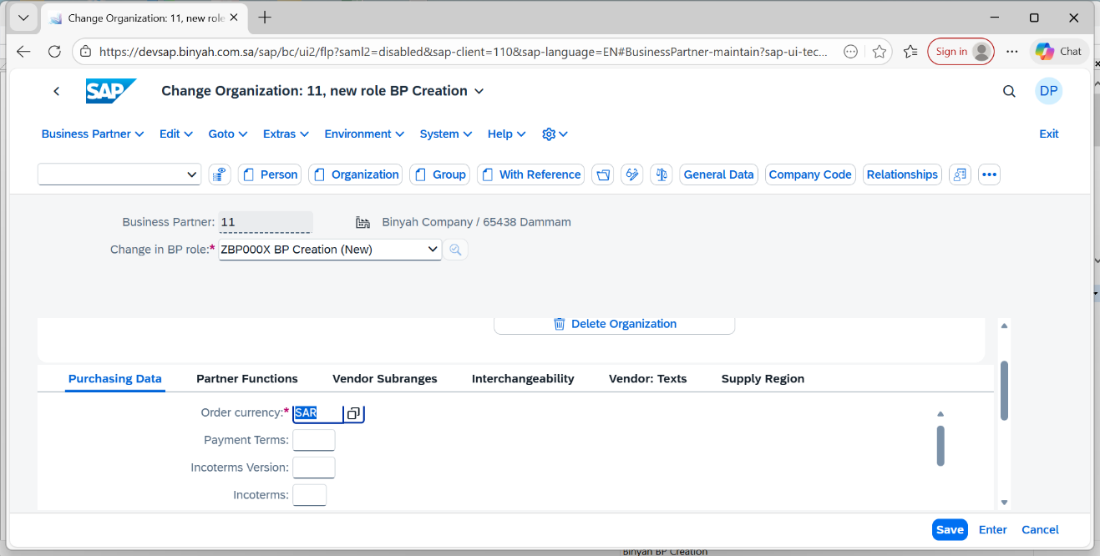

| Step | Action |
| --- | --- |
|  | **Now press "Enter".** |

Change Organization: 11, new role BP Creation - Personal - Microsoft​ Edge

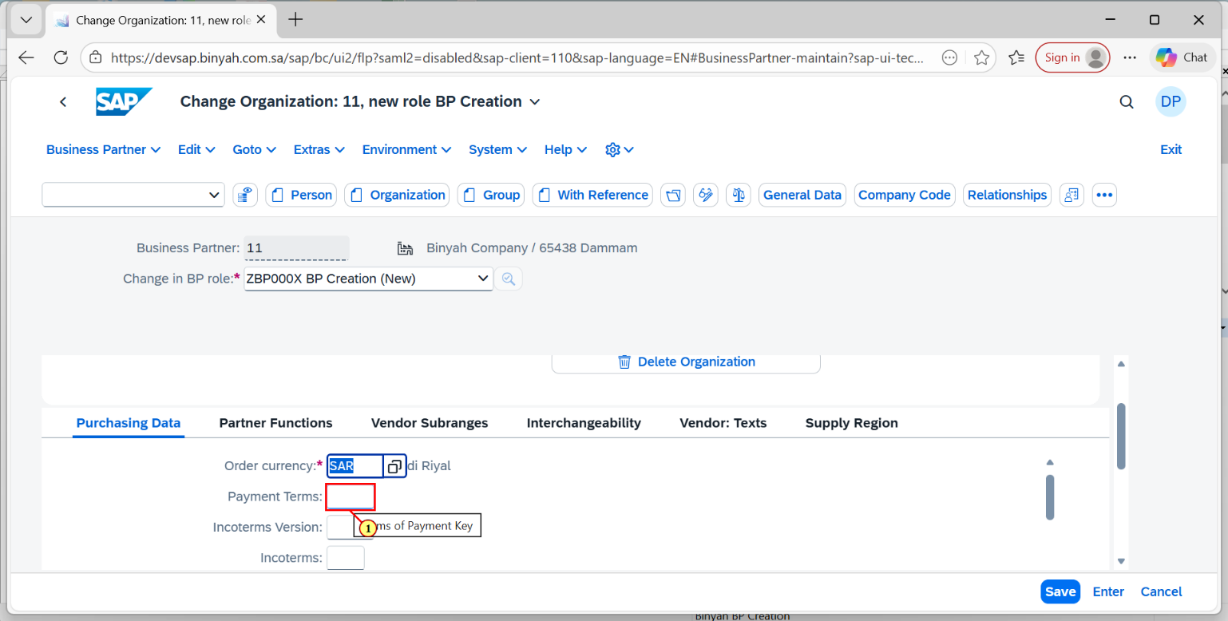

| Step | Action |
| --- | --- |
| (1) | Click on Payment terms Field to enter the term. |

Change Organization: 11, new role BP Creation - Personal - Microsoft​ Edge

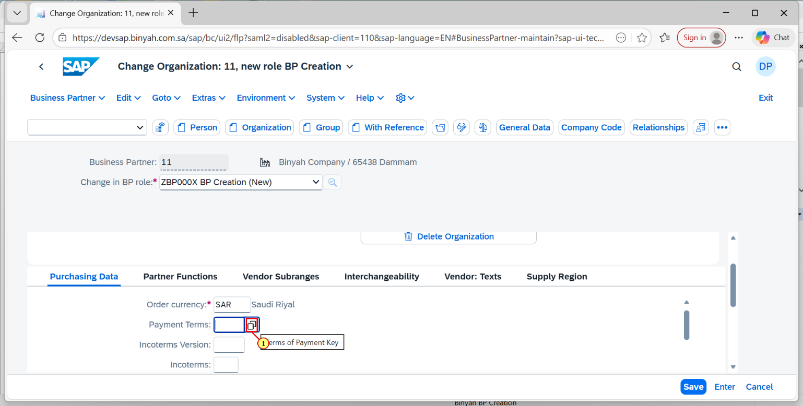

| Step | Action |
| --- | --- |
| (1) | Click on Search help of Payment Terms. |

Change Organization: 11, new role BP Creation - Personal - Microsoft​ Edge

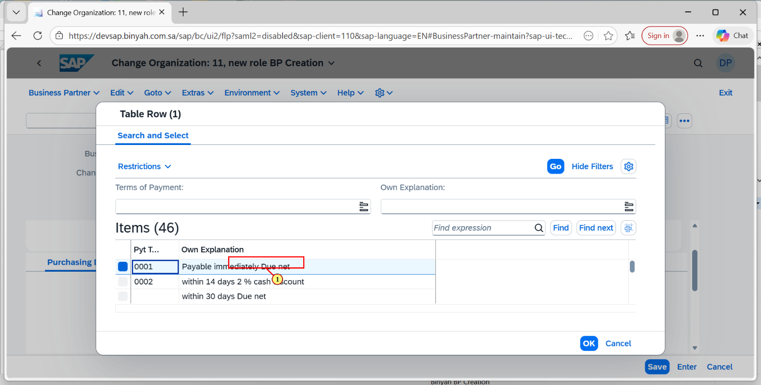

| Step | Action |
| --- | --- |
| (1) | After clicking on Search help it will navigate to this page.Here select the payment term that you want. |

Change Organization: 11, new role BP Creation - Personal - Microsoft​ Edge

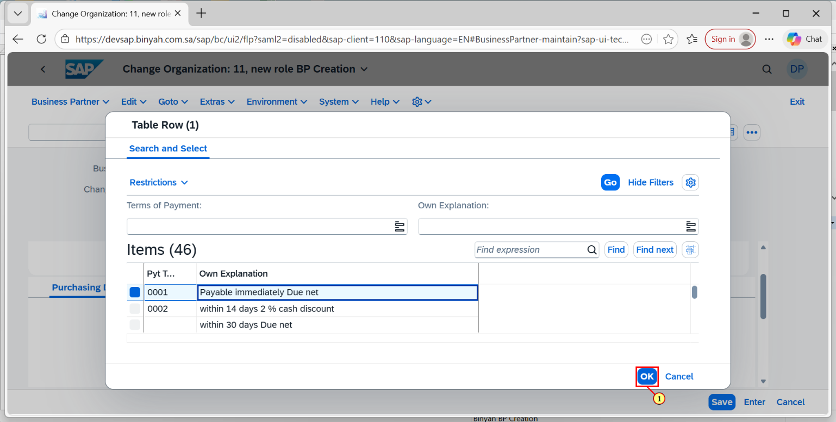

| Step | Action |
| --- | --- |
| (1) | Now click on "OK". |

Change Organization: 11, new role BP Creation - Personal - Microsoft​ Edge

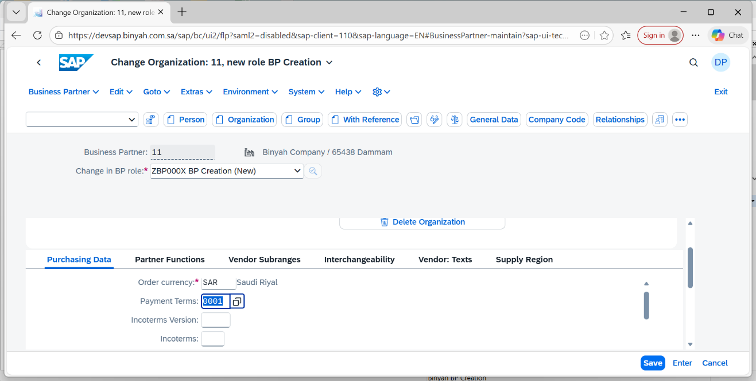

| Step | Action |
| --- | --- |
|  | **Now press "Enter".** |

Change Organization: 11, new role BP Creation - Personal - Microsoft​ Edge

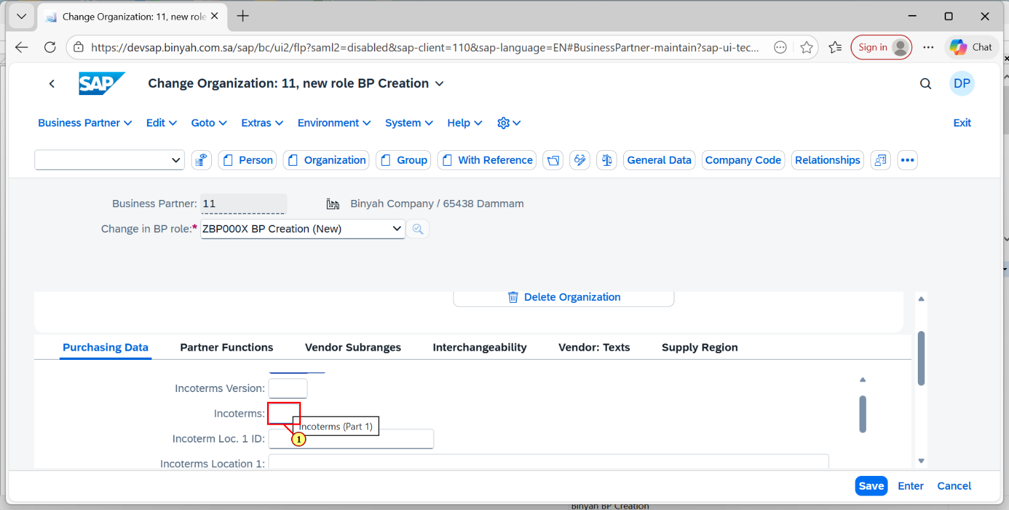

| Step | Action |
| --- | --- |
| (1) | Enter the Incoterms in the field. |

Change Organization: 11, new role BP Creation - Personal - Microsoft​ Edge

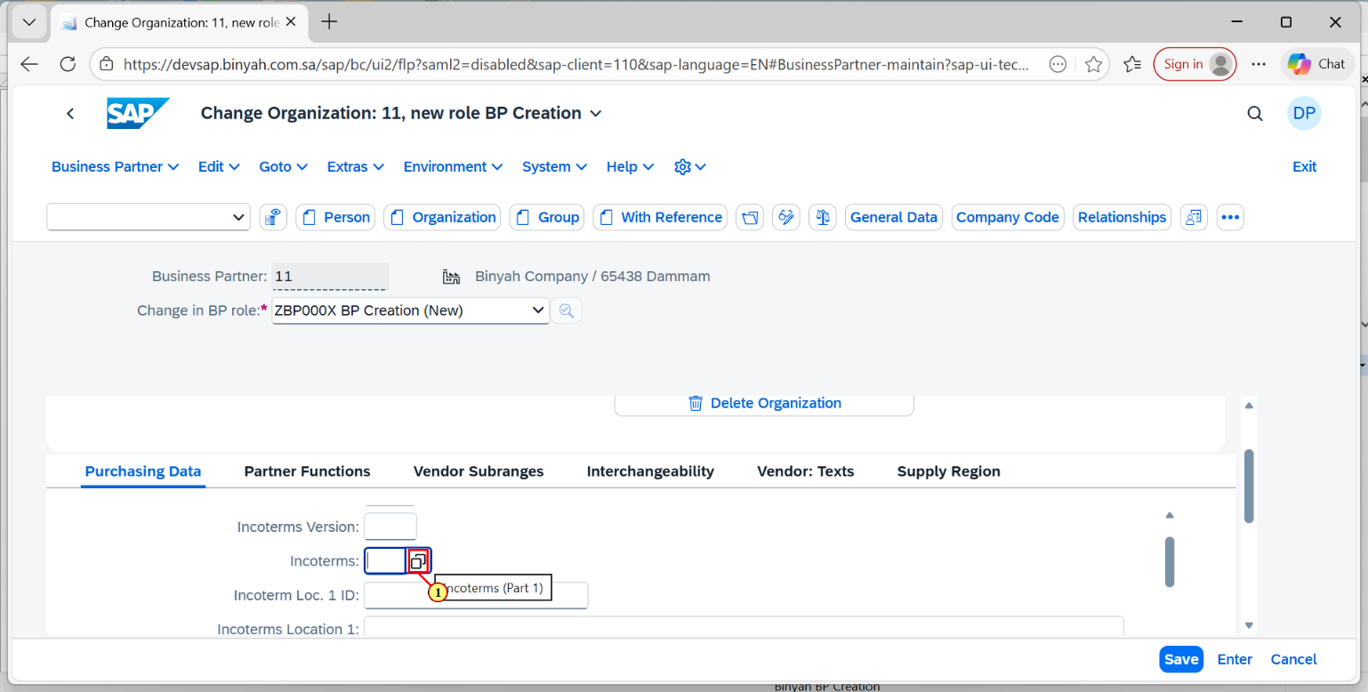

| Step | Action |
| --- | --- |
| (1) | Click on Search help icon of Incoterms. |

Change Organization: 11, new role BP Creation - Personal - Microsoft​ Edge

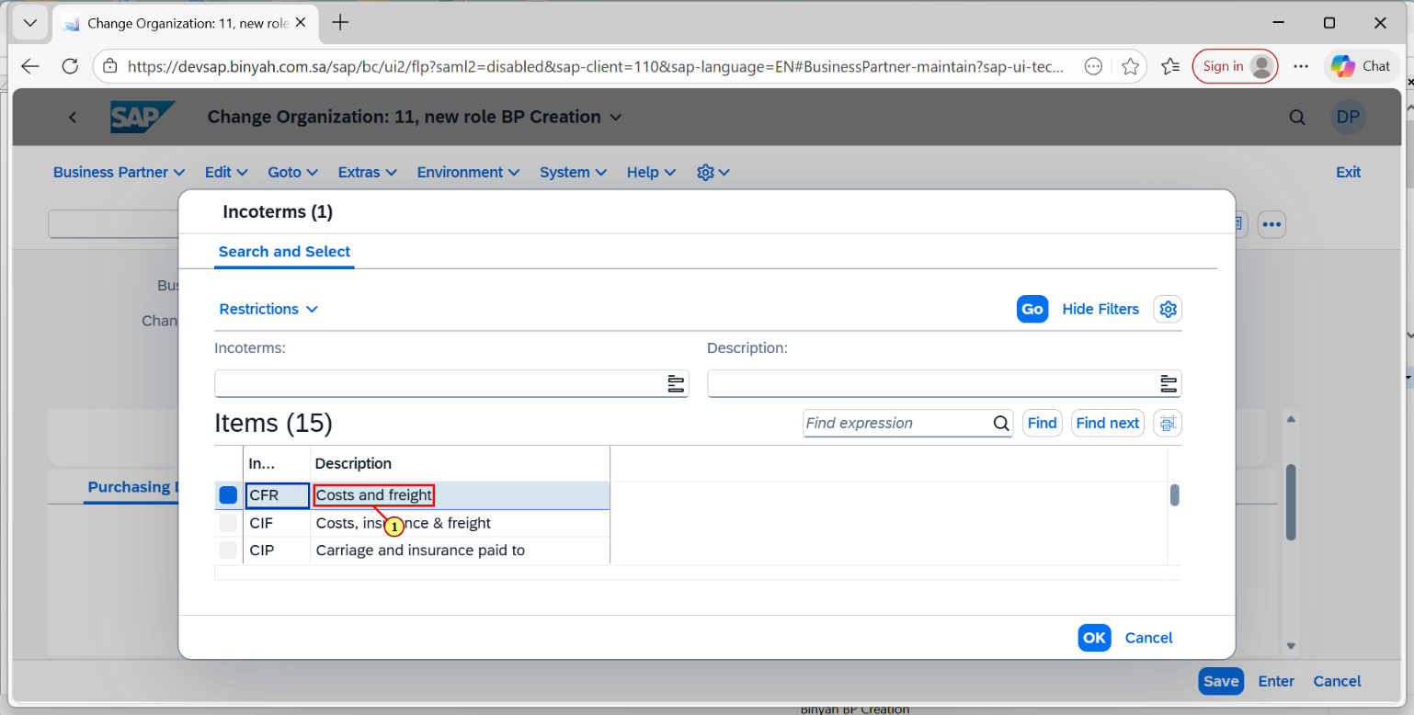

| Step | Action |
| --- | --- |
| (1) | **Now click the Item that we require from the list of items.** |

Change Organization: 11, new role BP Creation - Personal - Microsoft​ Edge

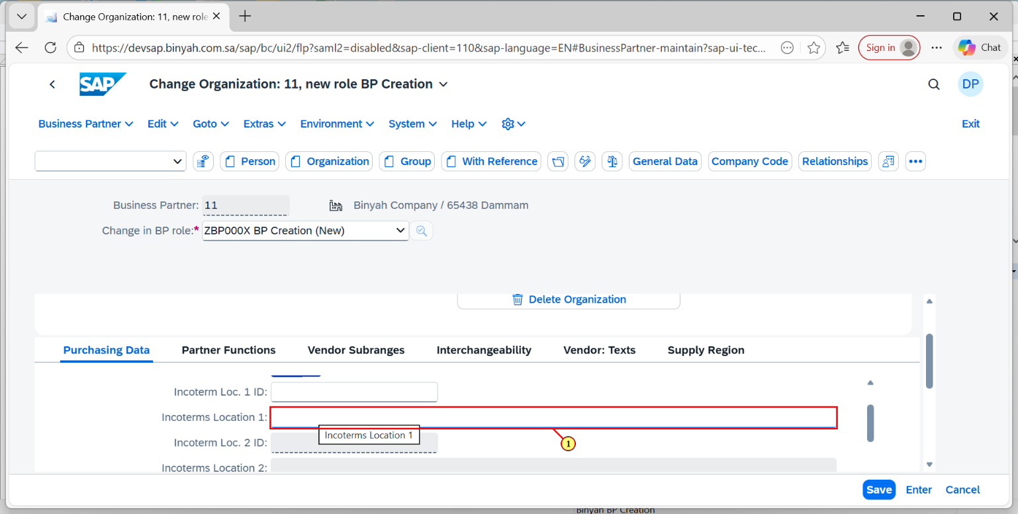

| Step | Action |
| --- | --- |
| (1) | In this field Click and enter the Incoterm location 1. |

Change Organization: 11, new role BP Creation - Personal - Microsoft​ Edge

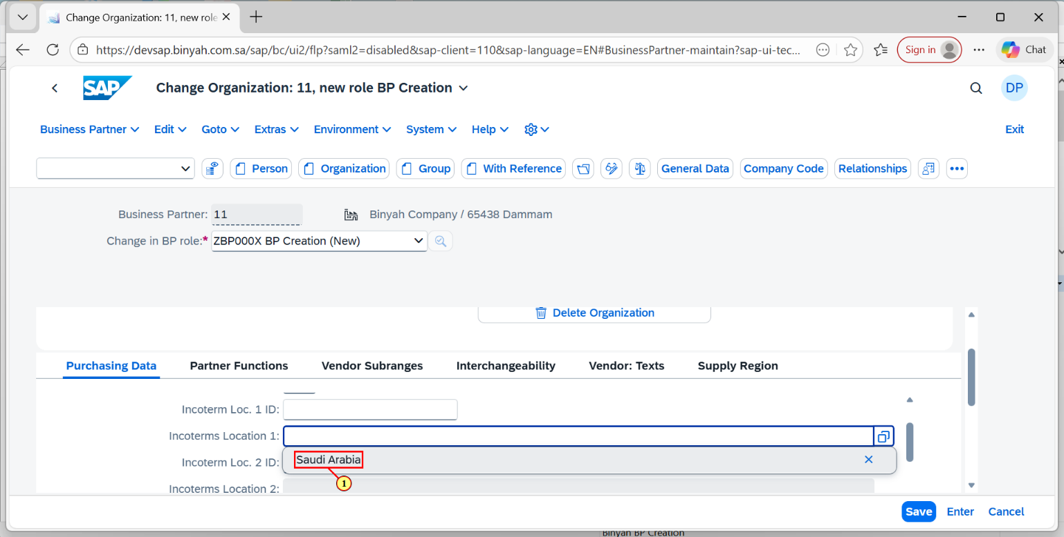

| Step | Action |
| --- | --- |
| (1) | Here it is entered as "Saudi Arabia " and then click "Enter". |

Change Organization: 11, new role BP Creation - Personal - Microsoft​ Edge

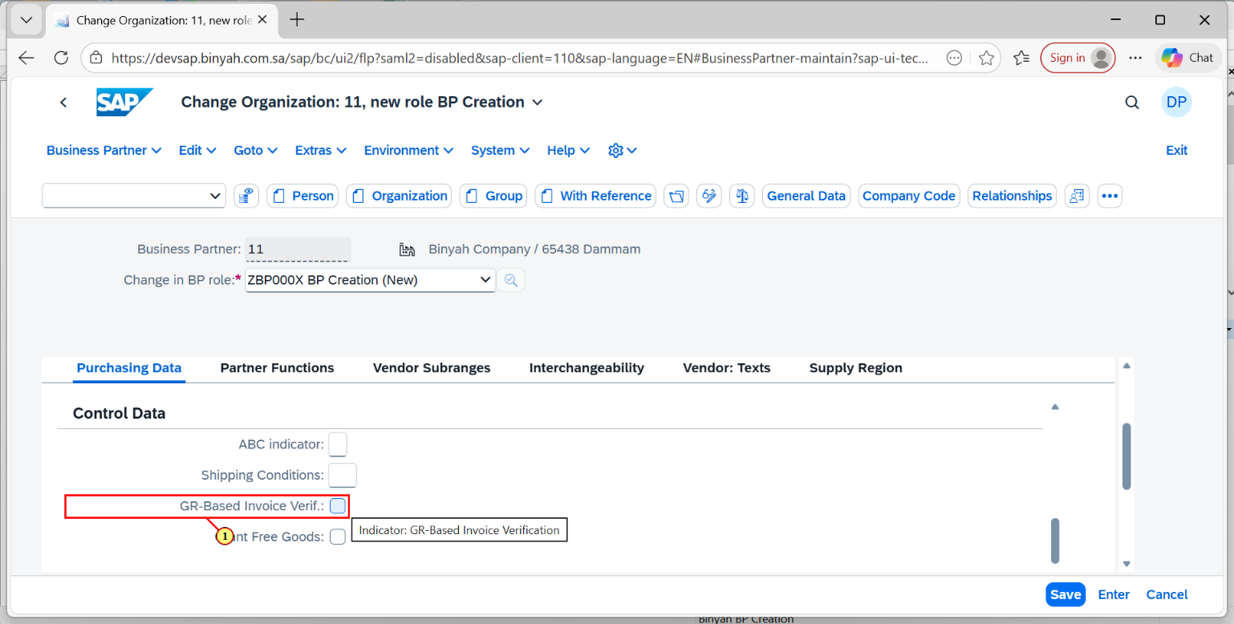

| Step | Action |
| --- | --- |
| (1) | Now make a click for GR-Based Invoice Verification "CheckBox". |

Change Organization: 11, new role BP Creation - Personal - Microsoft​ Edge

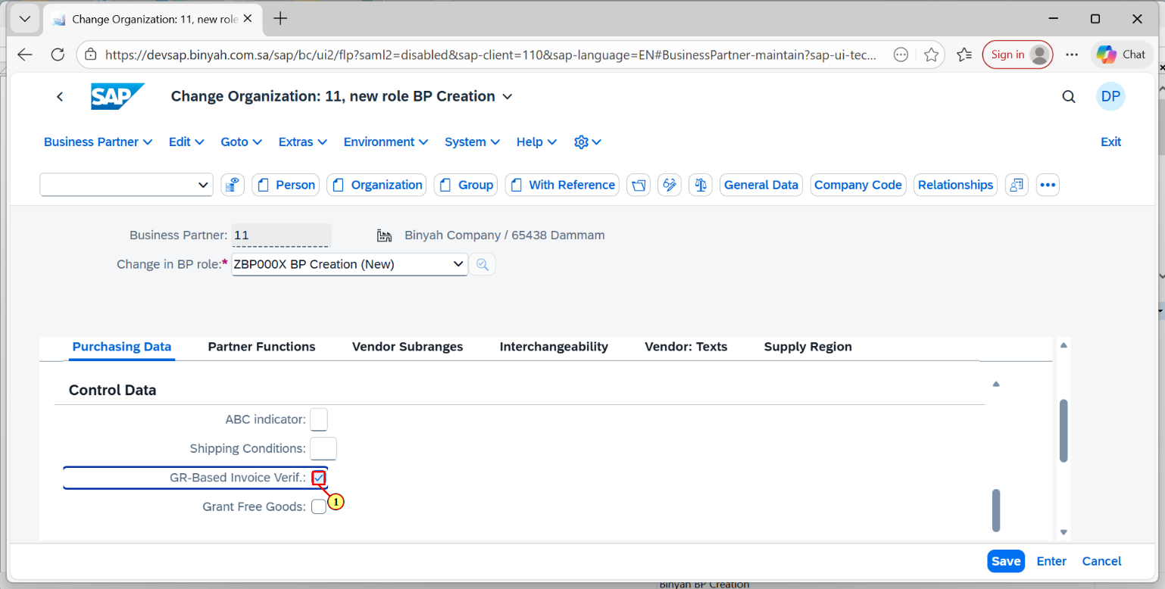

| Step | Action |
| --- | --- |
| (1) | Make the Checkbox "Ticked". |

Change Organization: 11, new role BP Creation - Personal - Microsoft​ Edge

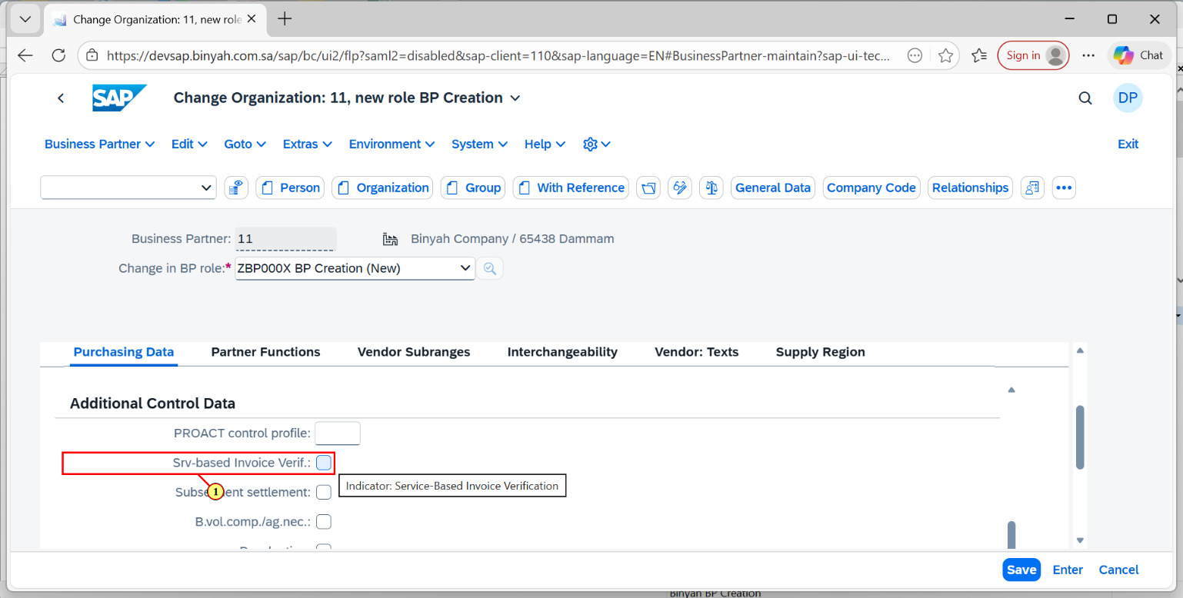

| Step | Action |
| --- | --- |
| (1) | Make the Srv-based Invoice Verification checkbox "Ticked". |

Change Organization: 11, new role BP Creation - Personal - Microsoft​ Edge

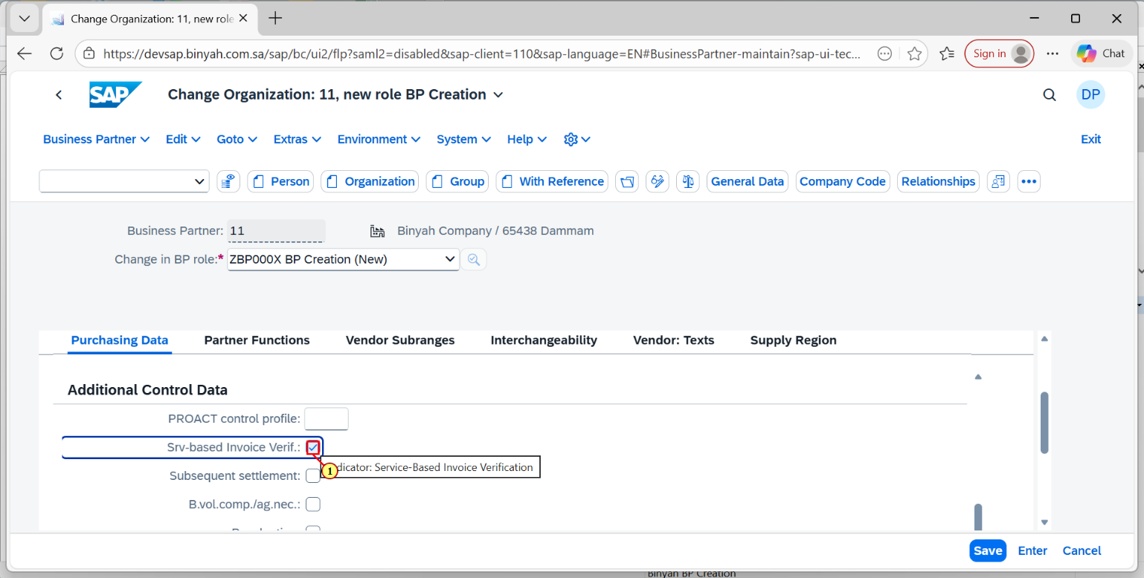

| Step | Action |
| --- | --- |
| (1) | Make sure it is "Ticked" like this. |

Change Organization: 11, new role BP Creation - Personal - Microsoft​ Edge

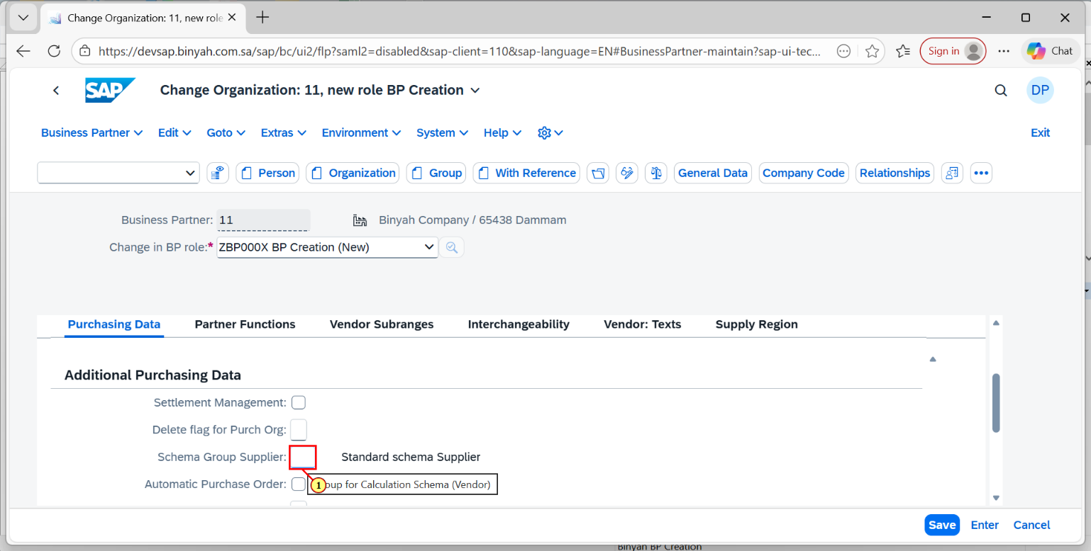

| Step | Action |
| --- | --- |
| (1) | Enter the Schema Group Supplier in this Field. |

Change Organization: 11, new role BP Creation - Personal - Microsoft​ Edge

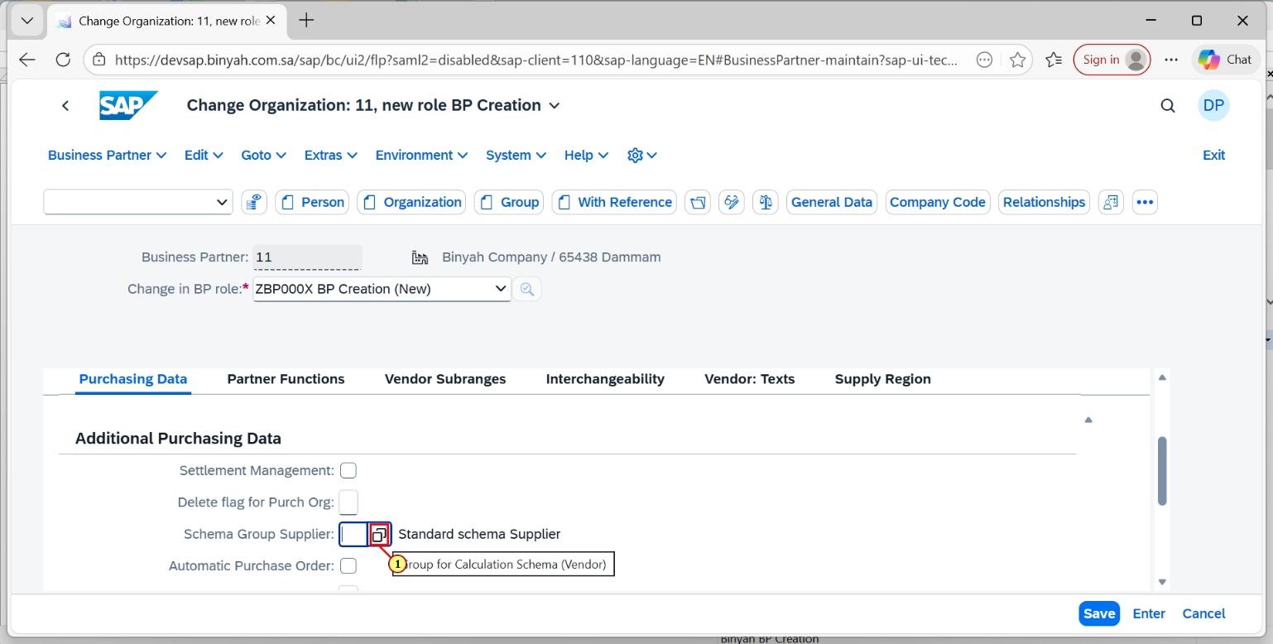

| Step | Action |
| --- | --- |
| (1) | Click on the search help icon of schema group. |

Change Organization: 11, new role BP Creation - Personal - Microsoft​ Edge

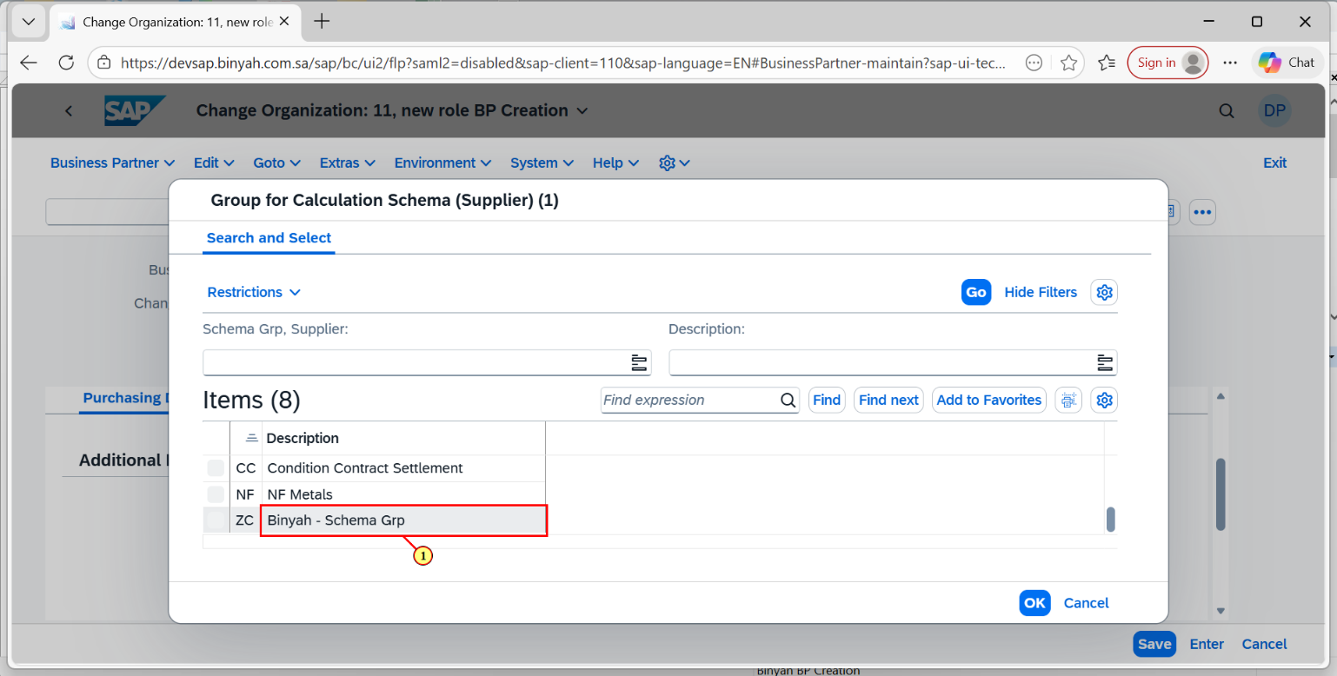

| Step | Action |
| --- | --- |
| (1) | After clicking on search help the page will be navigated. Here choose the required item. |

Change Organization: 11, new role BP Creation - Personal - Microsoft​ Edge

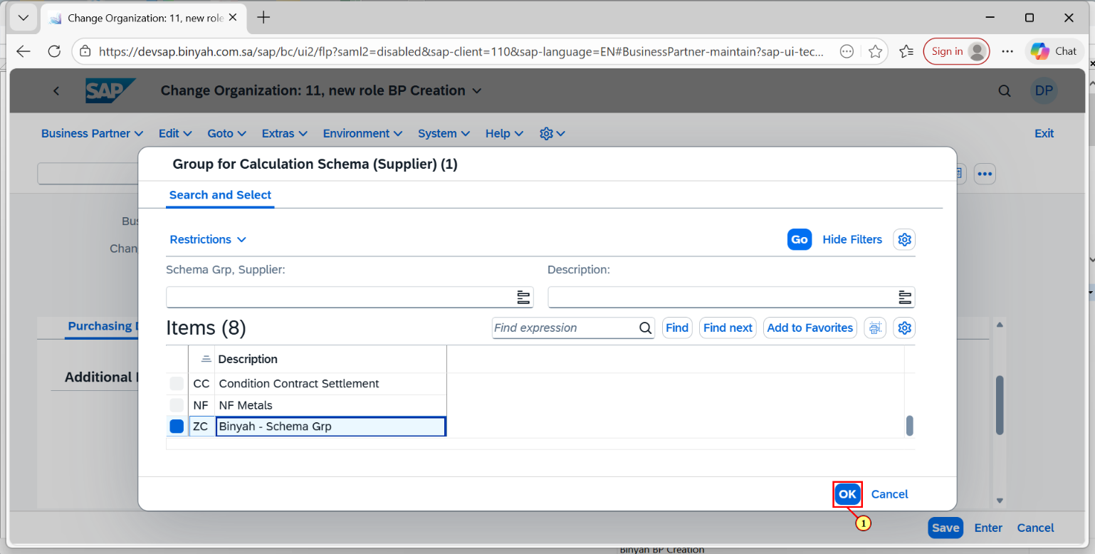

| Step | Action |
| --- | --- |
| (1) | Now click on "OK". |

Change Organization: 11, new role BP Creation - Personal - Microsoft​ Edge

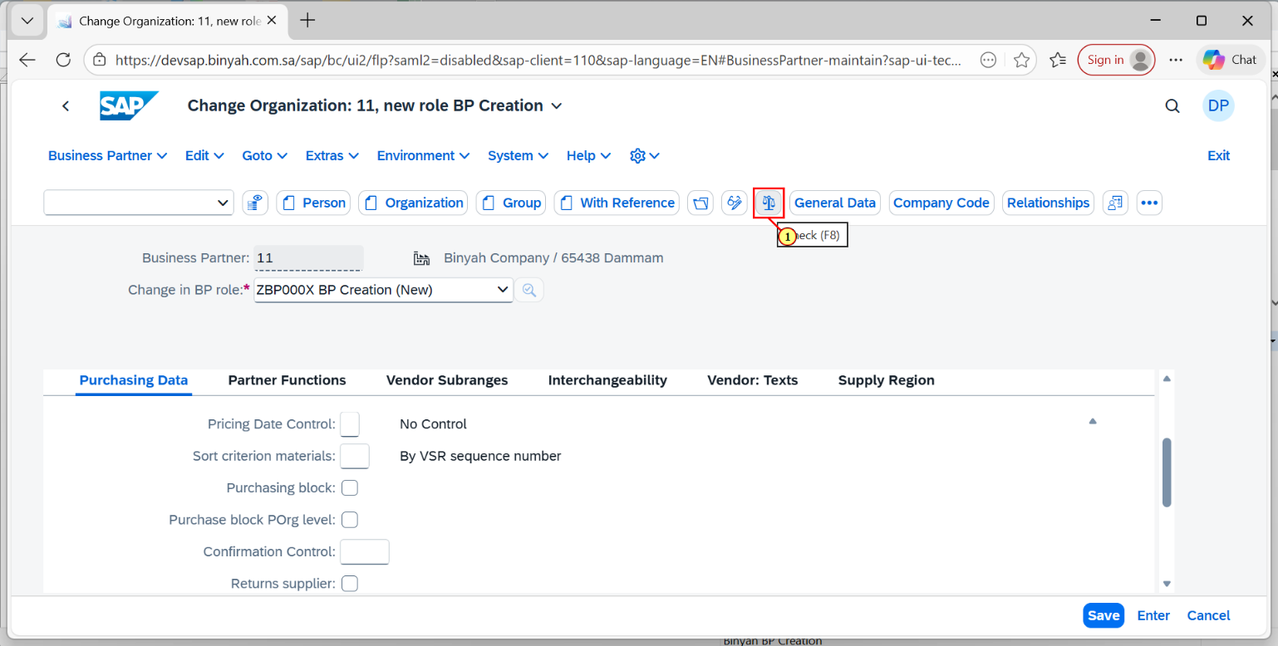

| Step | Action |
| --- | --- |
| (1) | After filling all the details click on "Check" and after that click on "Save". |

Change Organization: 11, new role BP Creation - Personal - Microsoft​ Edge